Problem Solving a Database Project

Advanced Databases

Arden university

­­

Table of Contents

**Part. I Database Design.3**

Normalized Data3

EERD5

**Part. II Implementation.** 13

Database Creation13

Creation of Tables14

**Part. III Data Insertion.** 21

Data Insertion21

**Part. IV Constraints,De-norm data,Index and Inheritance.** 29

Check Constraints29

Default Constraints 29

Increment Constraints 29

De-normalizations 30

Indexes 30

Inheritance 31

**Part. V Views,Storing Procedures and Triggers.**31

Views 31

Inheritance 31

Store Procedure 37

Triggers 45

References 54

Appendix 55

**Part. I Database Design.**

Not normalized data:

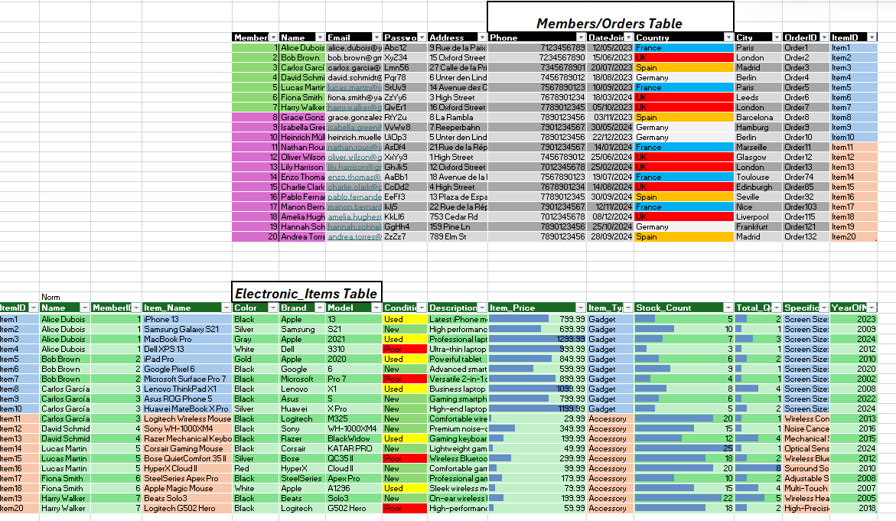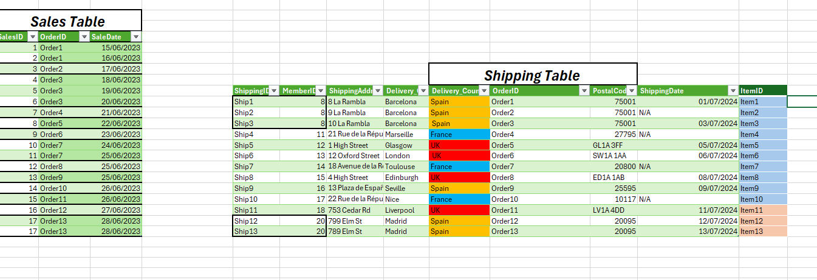

Normalized Data:

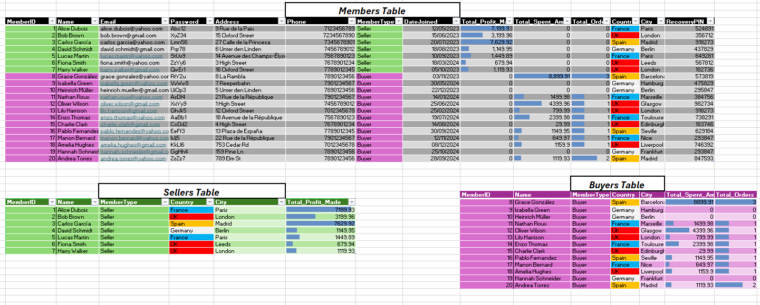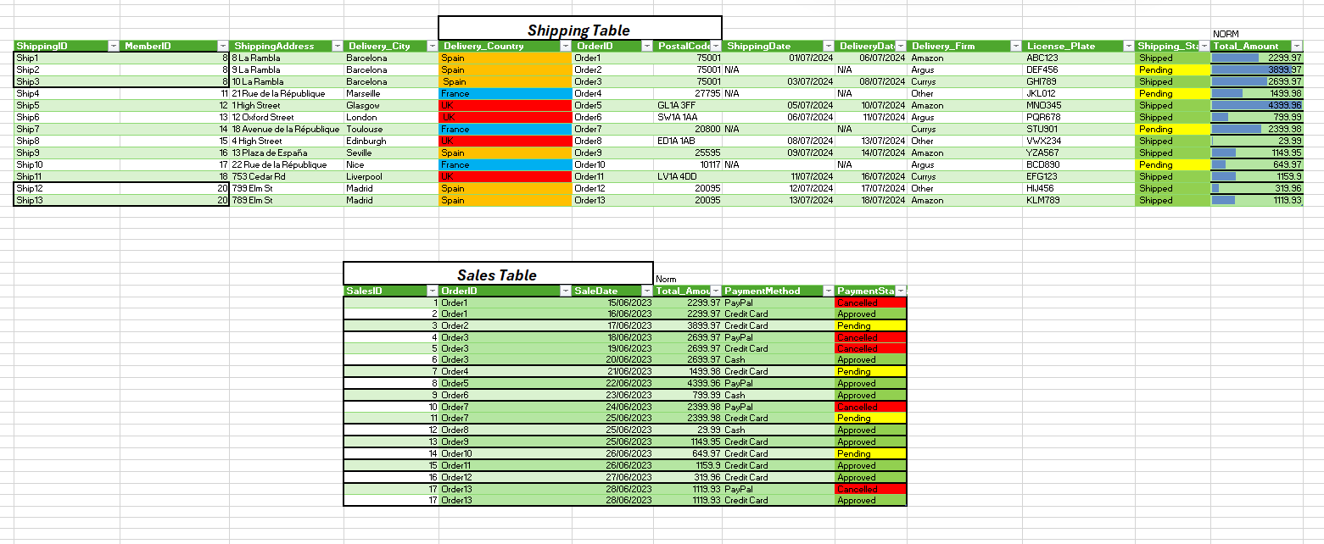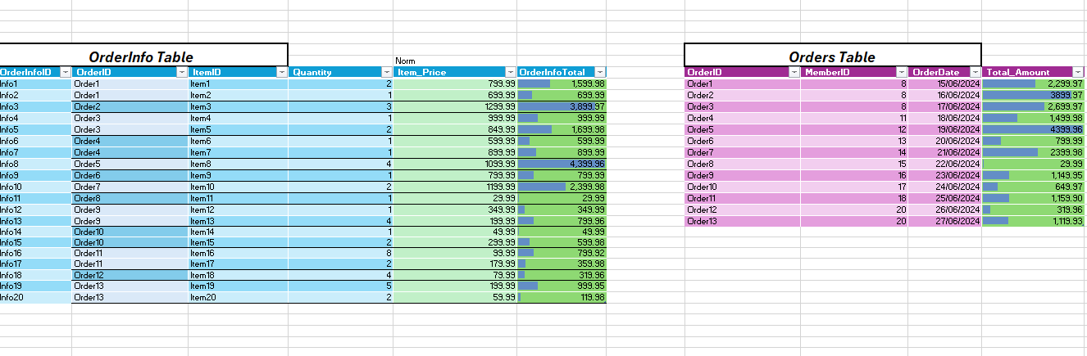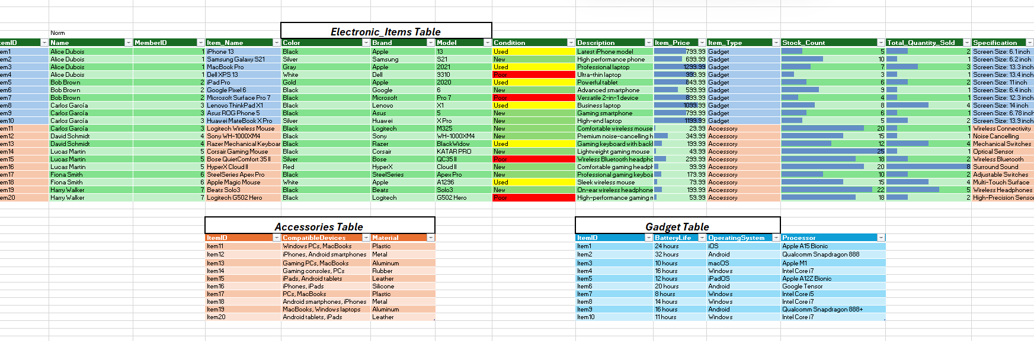

EERD

In my database design, I utilize an Enhanced Entity-Relationship Diagram (EERD) to effectively represent the intricacies of a system, surpassing the capability of a basic ERD.According to Ricky (2023), the EERD offers a comprehensive depiction of the relationships and constraints within the system, mirroring real-world interactions among entities. This diagram is adept at illustrating complex relationships and constraints between entities. For instance, the Members entity can be further categorized into Sellers and Buyers, delineating clear distinctions among user categories. This form of subclassing showcases how the EERD can accommodate hierarchical data, thereby enhancing the design with more detailed information. Additionally, the utilization of CHECK,DEFAULT, and INCREMENT constraints serves to further elevate the complexity and depth of the database design.

The EERD Diagram:

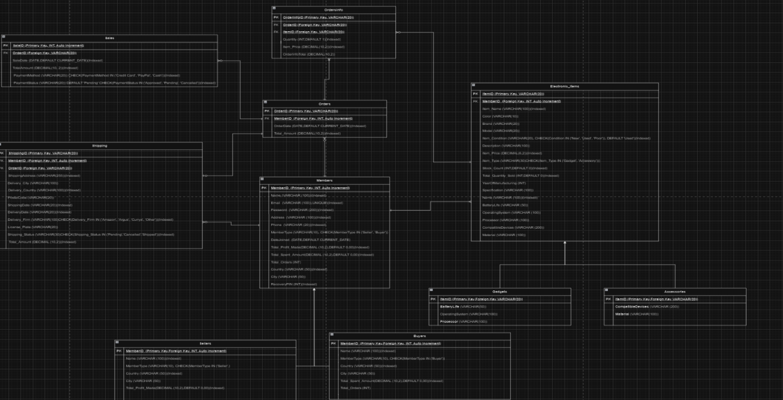

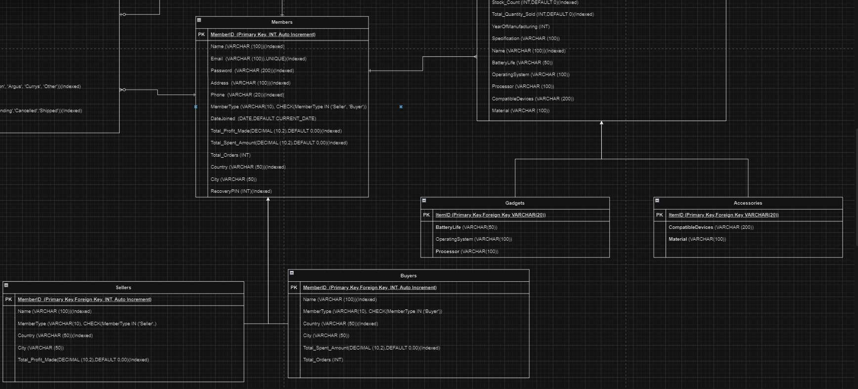

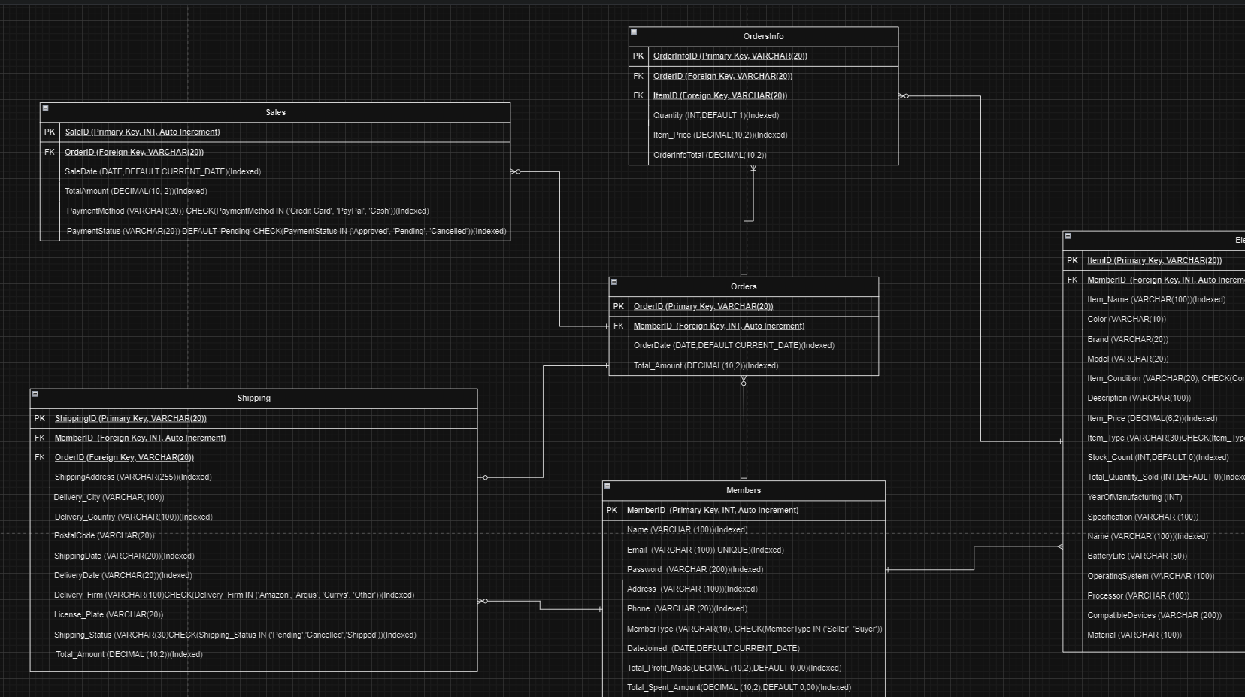

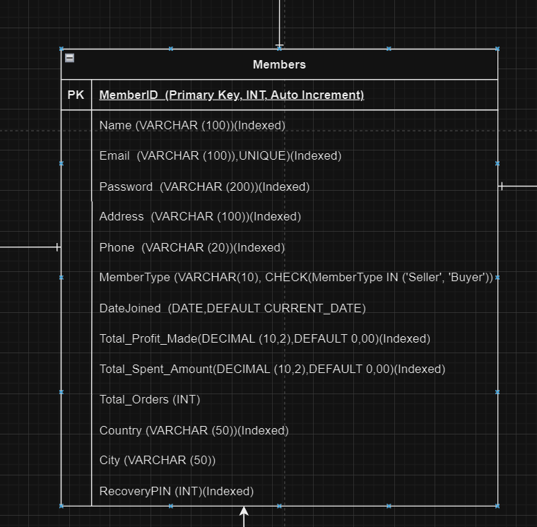

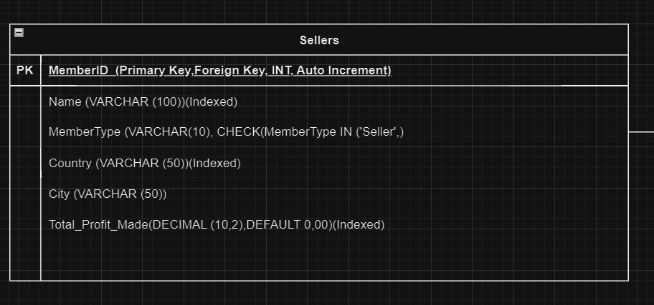

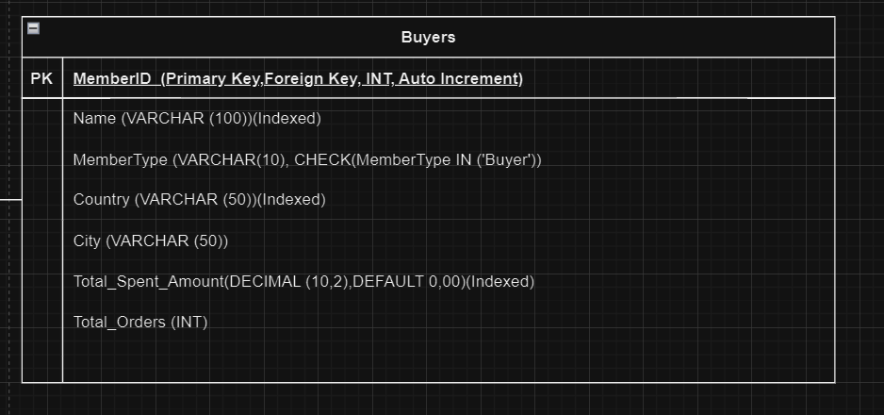

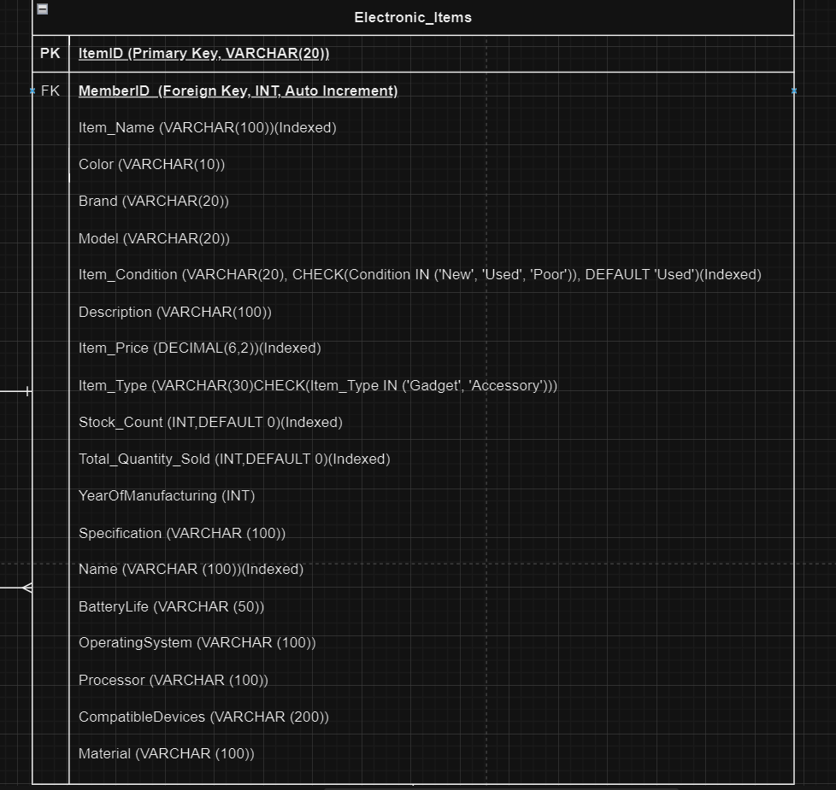

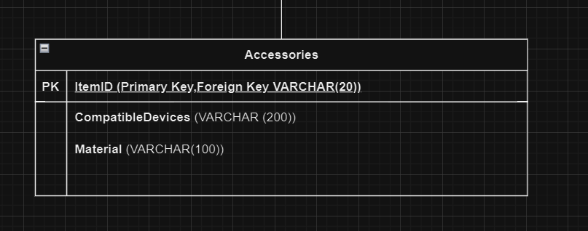

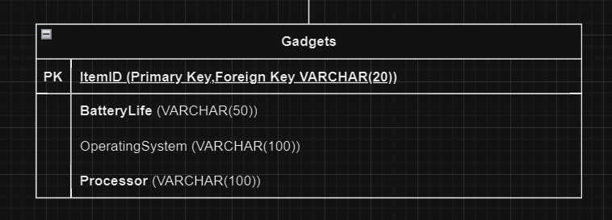

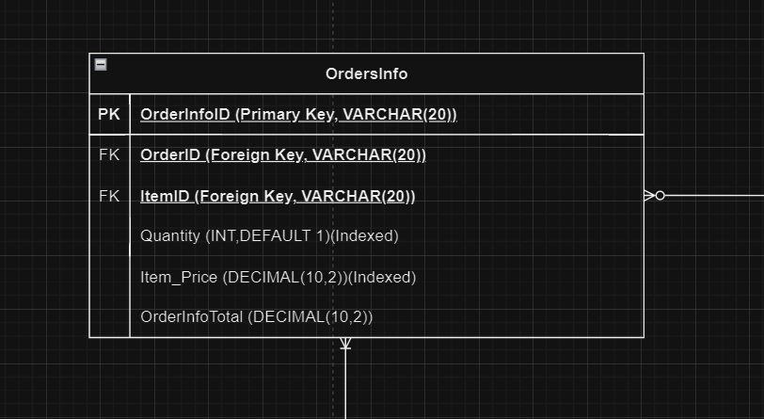

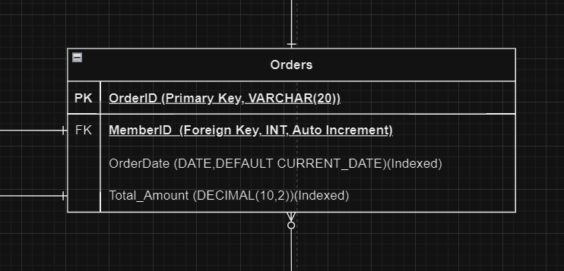

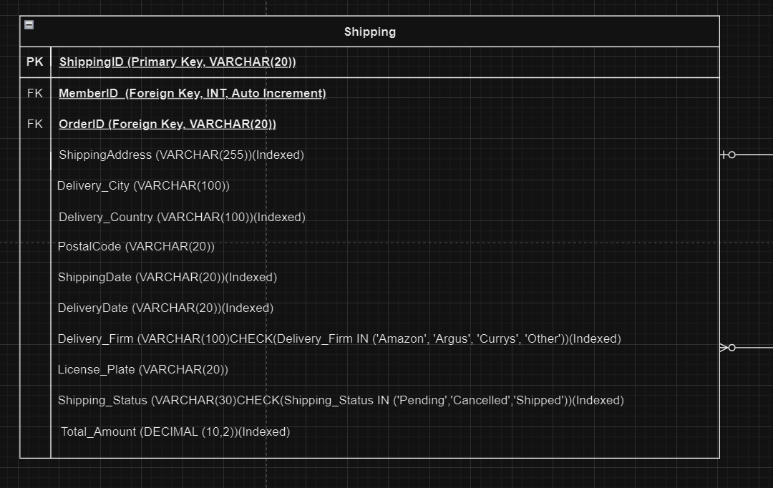

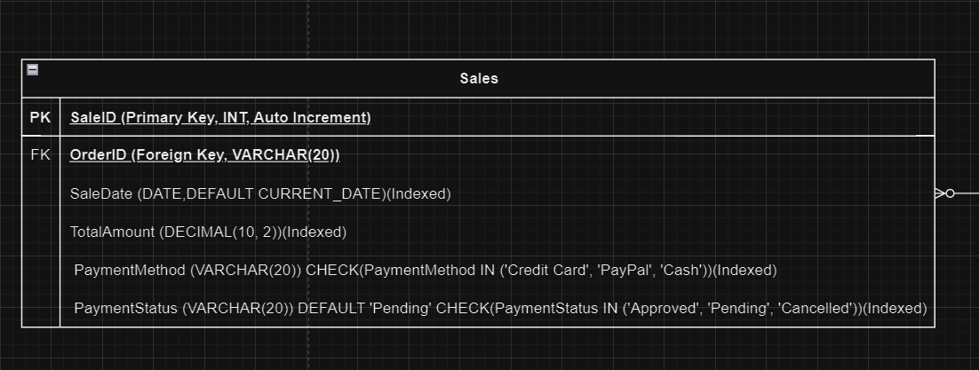

**Part. II Implementation.**

(full code in appendix)

Database creation:

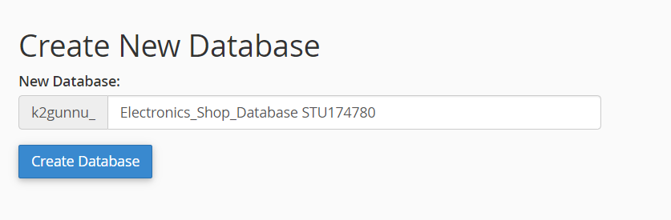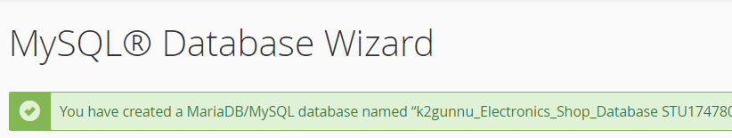

Creation of Tables:

Members creation: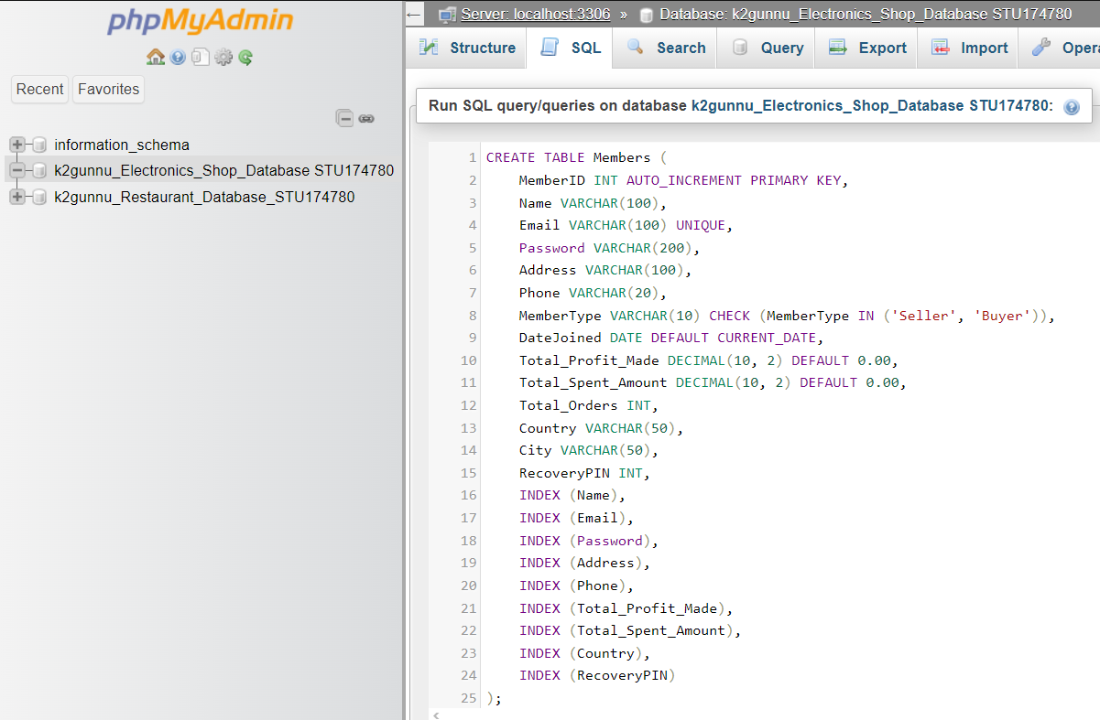

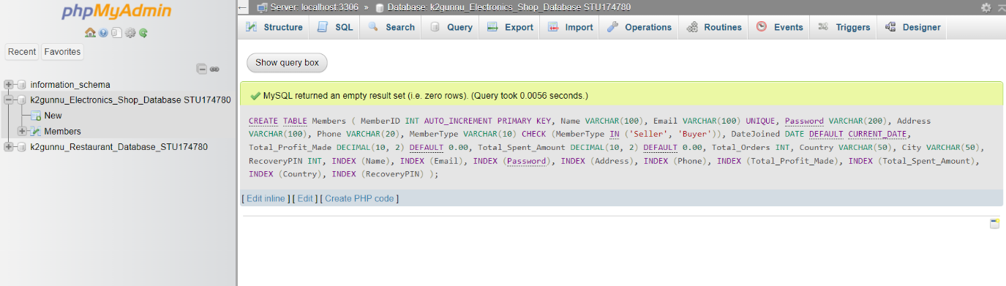

Shipping Creation:

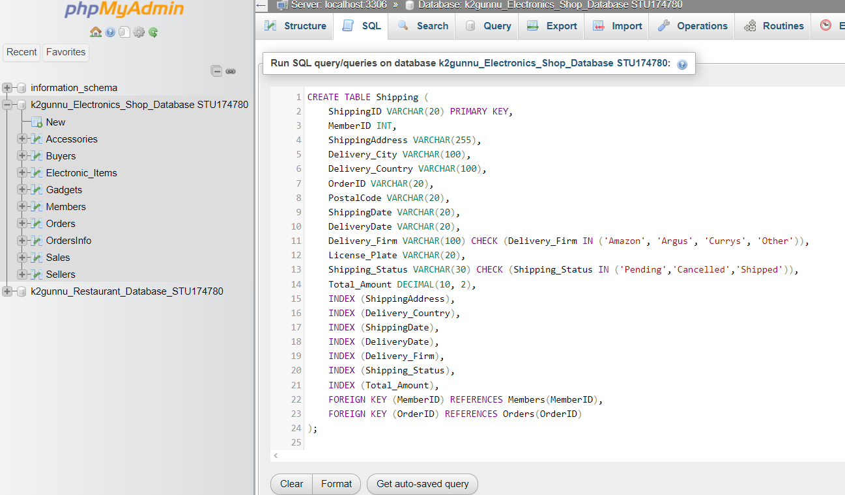

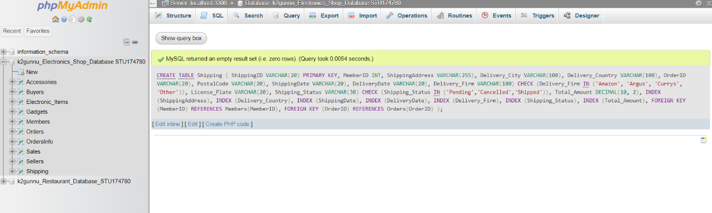

Orders Creation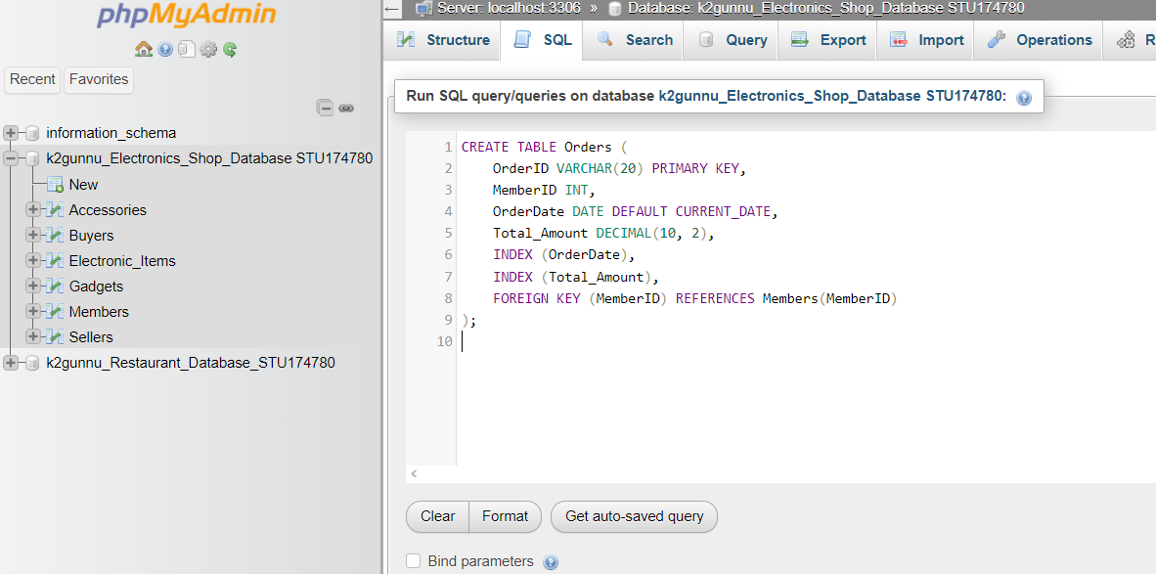

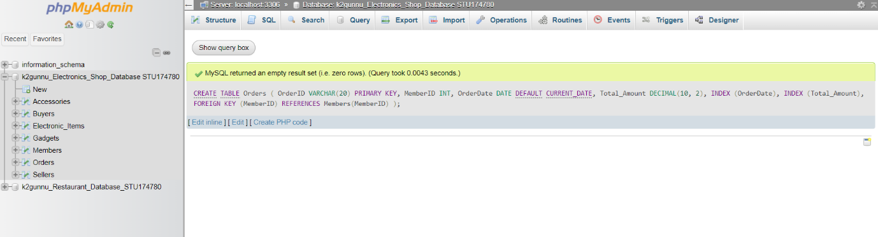

OrdersInfo Creation:

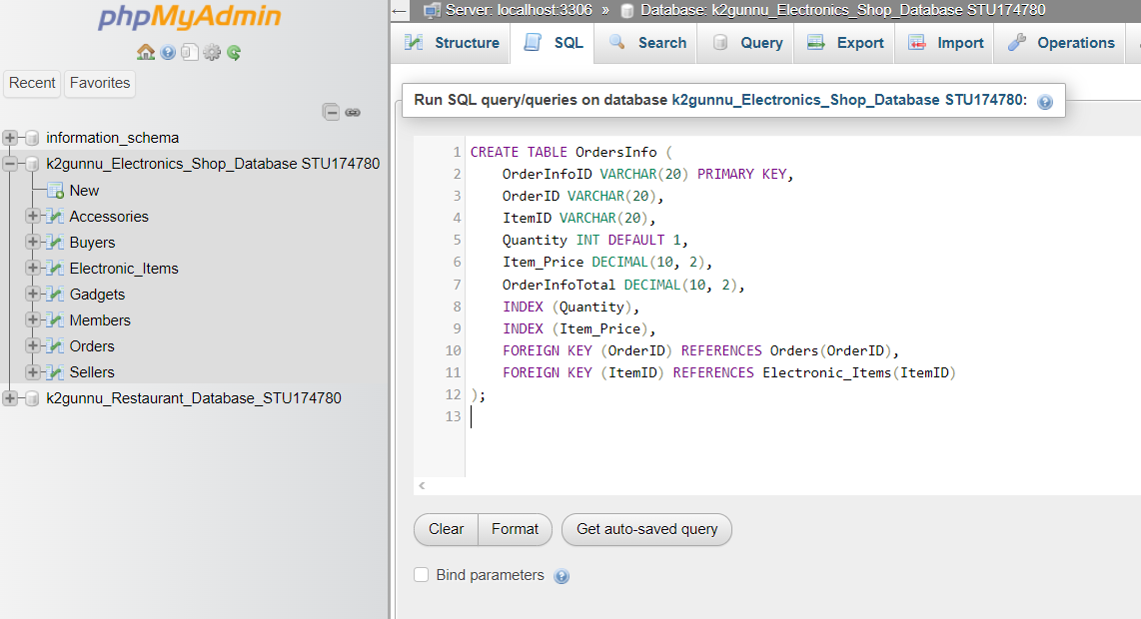

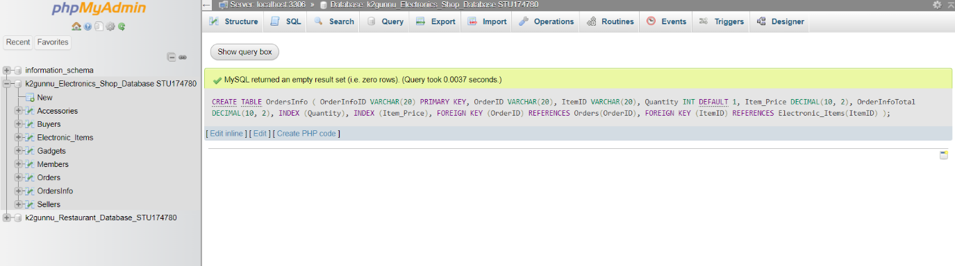

Sellers Creation:

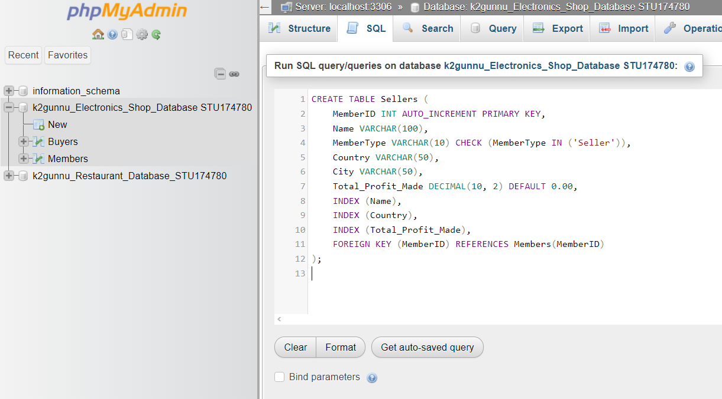

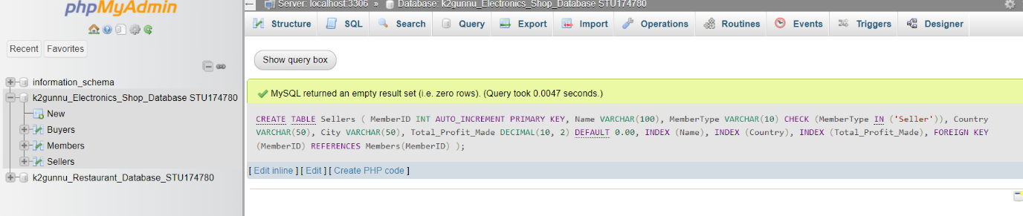

Buyer Creation:

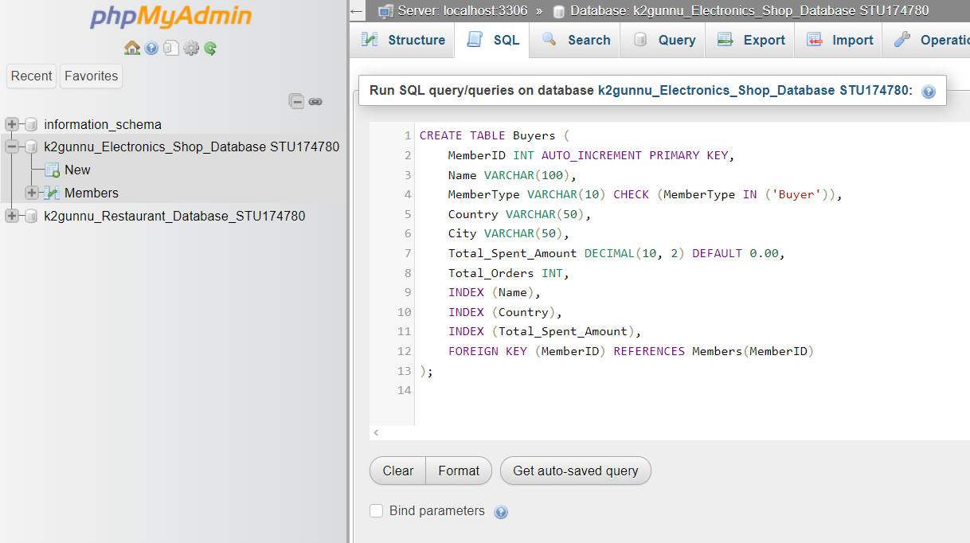

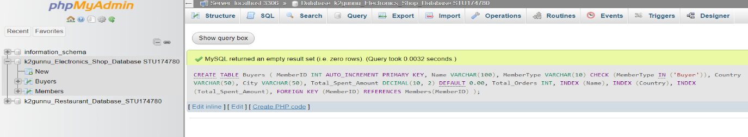

Electronic Items Creation:

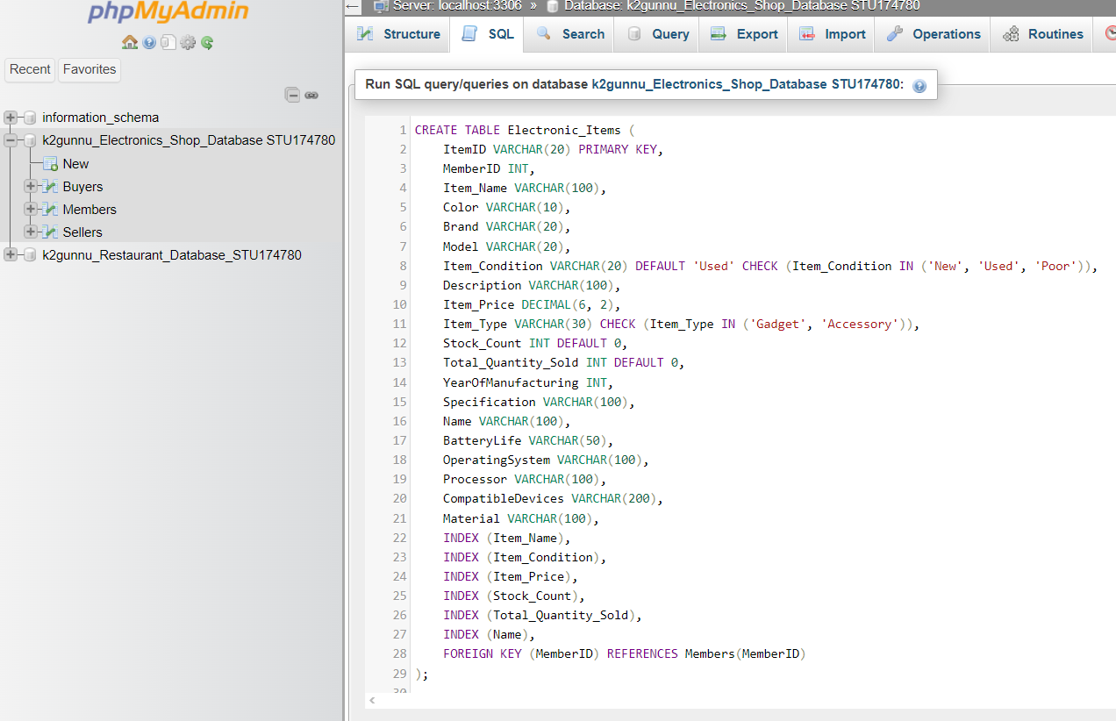

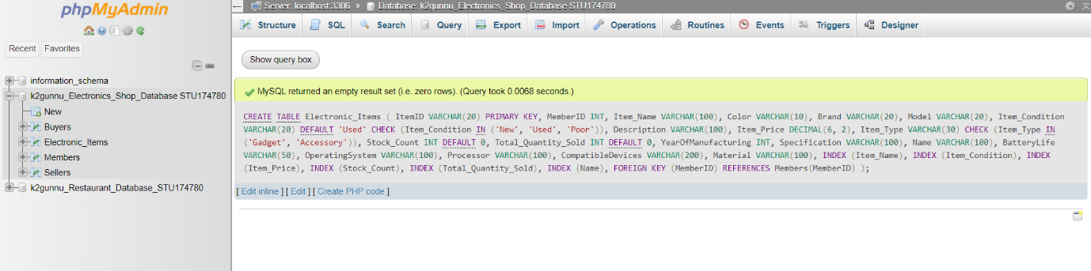

Accessories Creation:

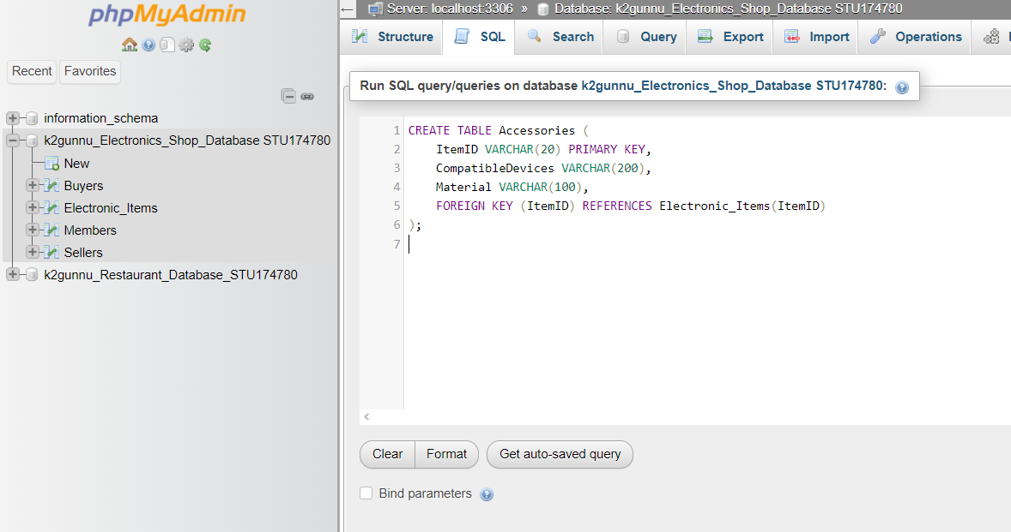

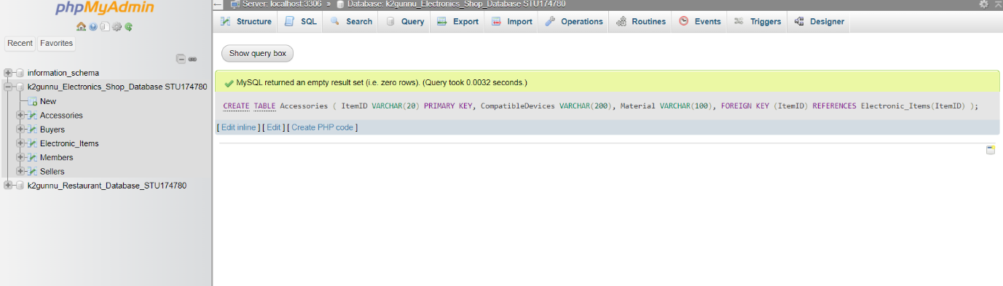

Gadgets Creation:

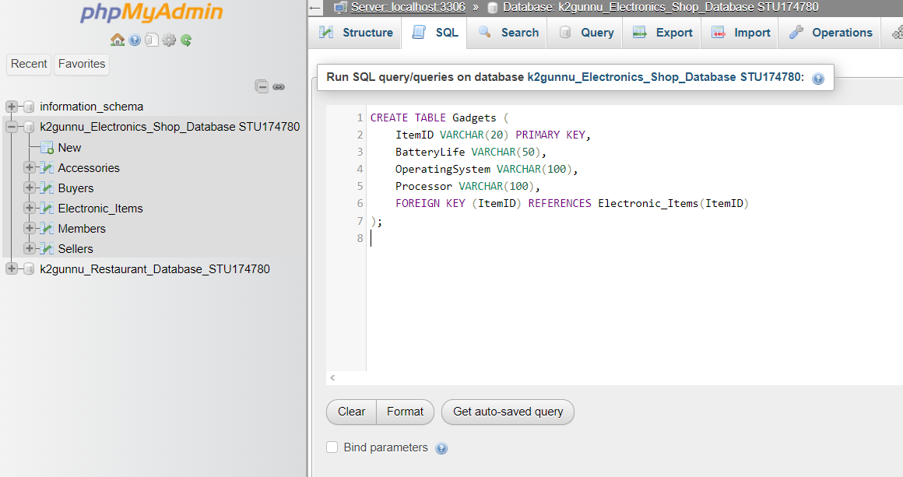

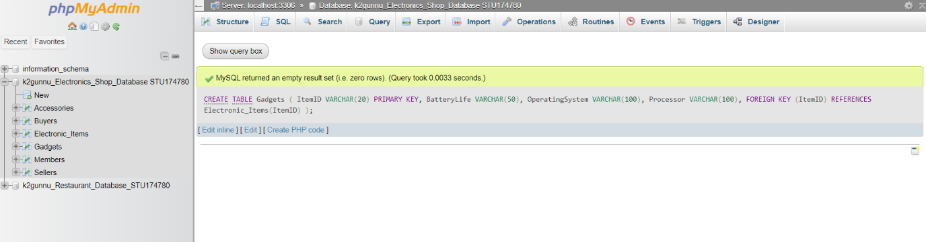

Sales Creation:

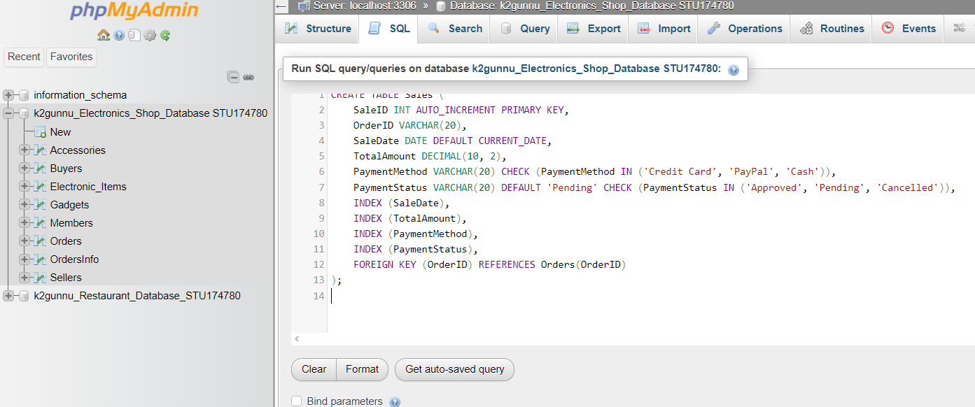

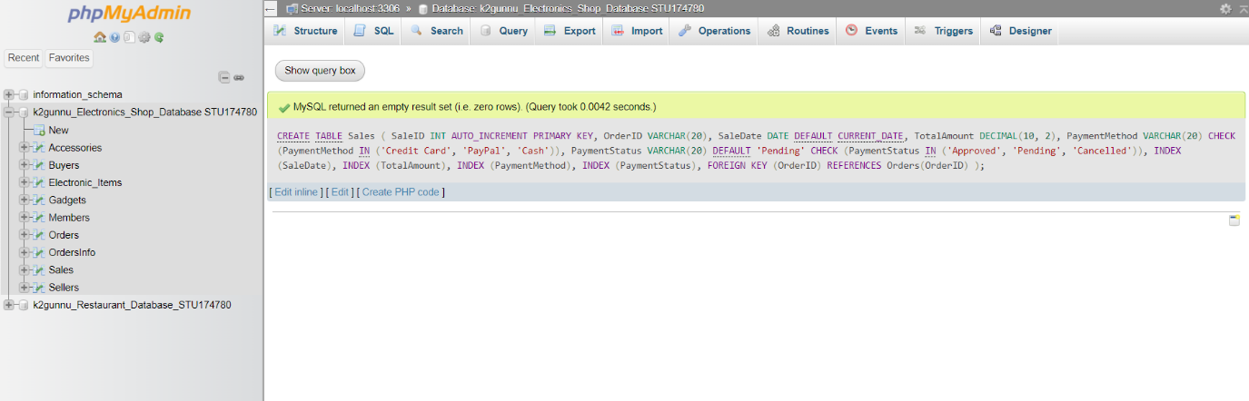

**Part. III Data Insertion.**

(full code in appendix)

Members Insert:

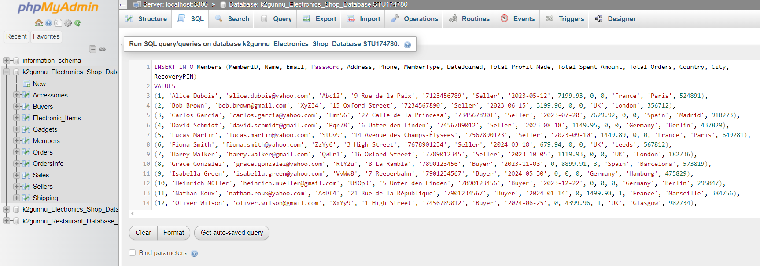

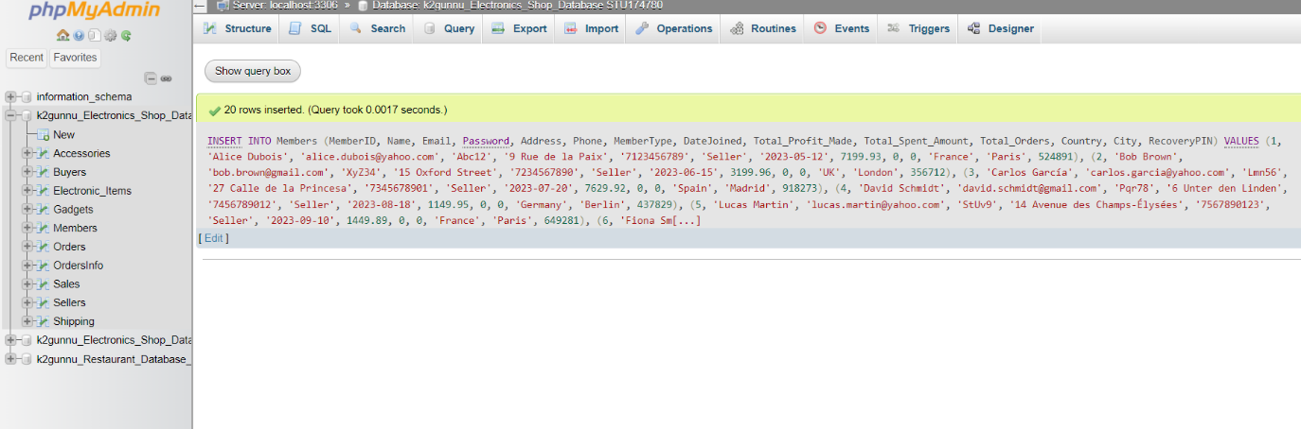

Sellers Insert:

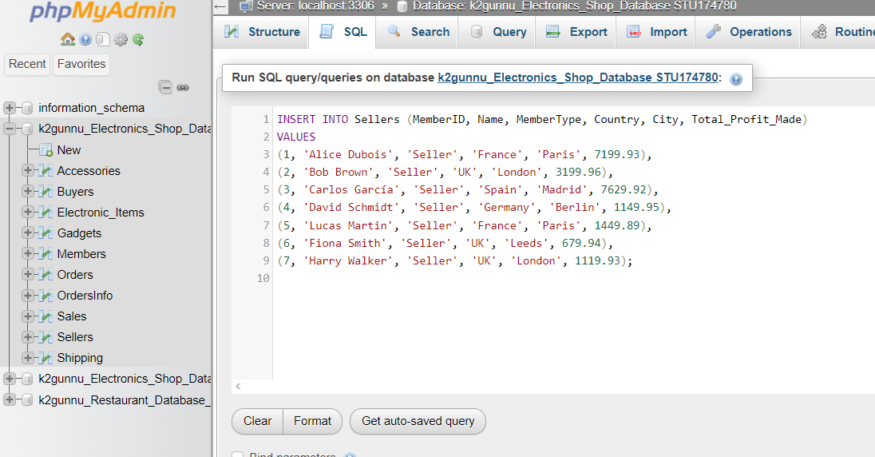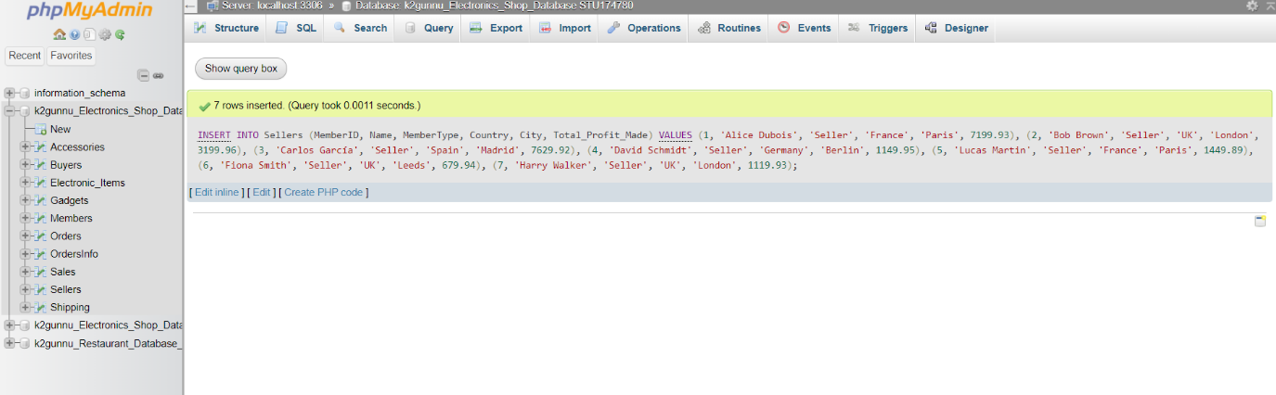

Buyers Insert: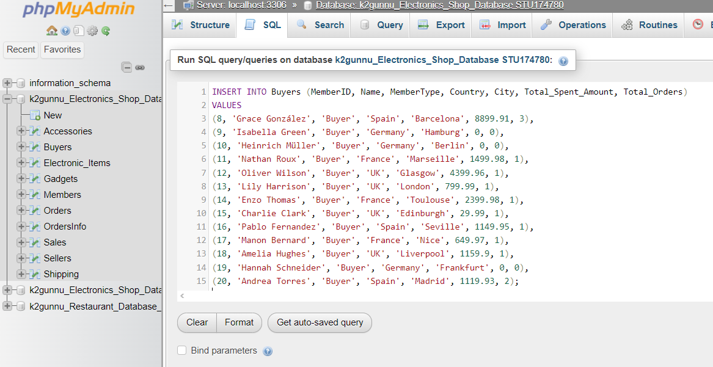

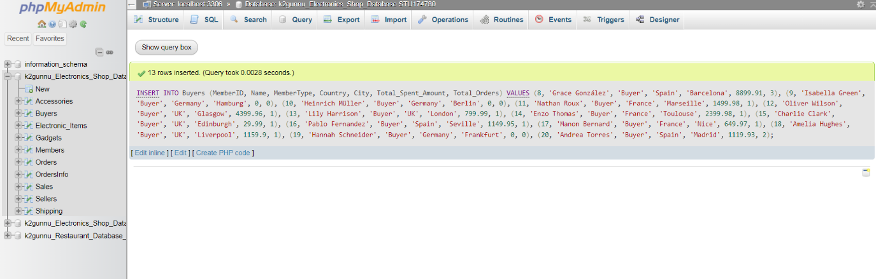

Electronics Insert:

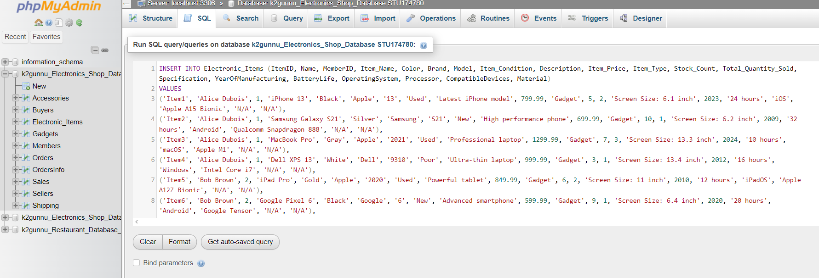

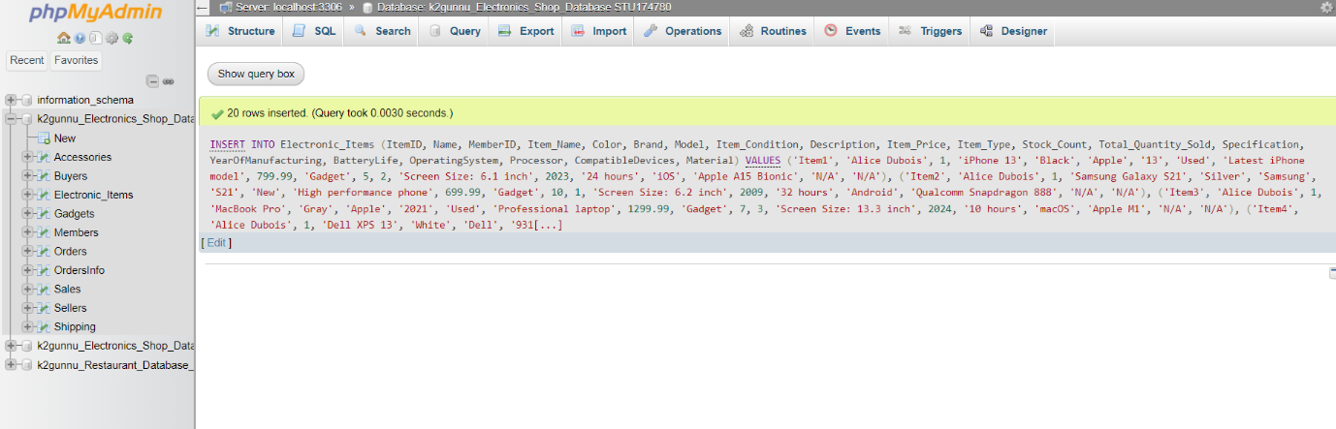

Gadgets Insert:

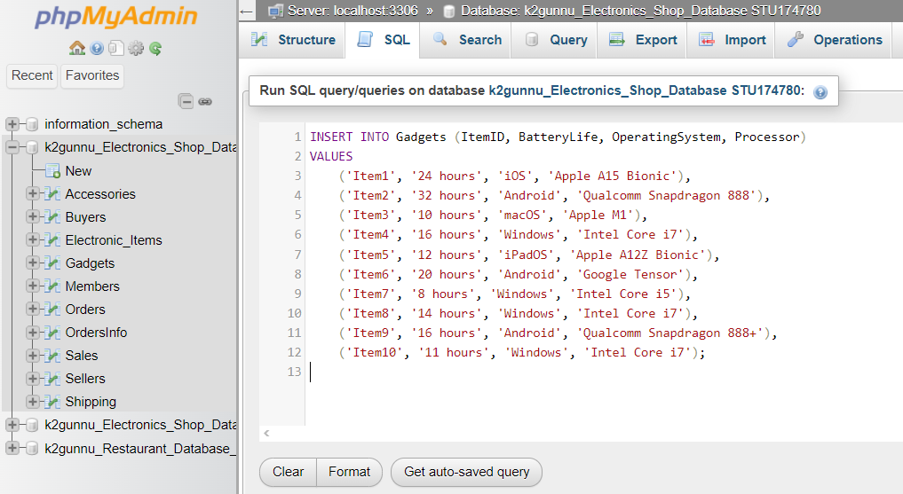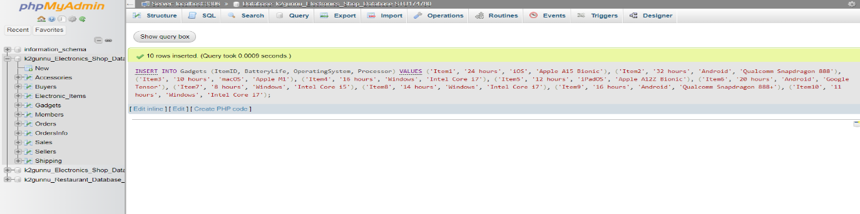

Accessories Insert:

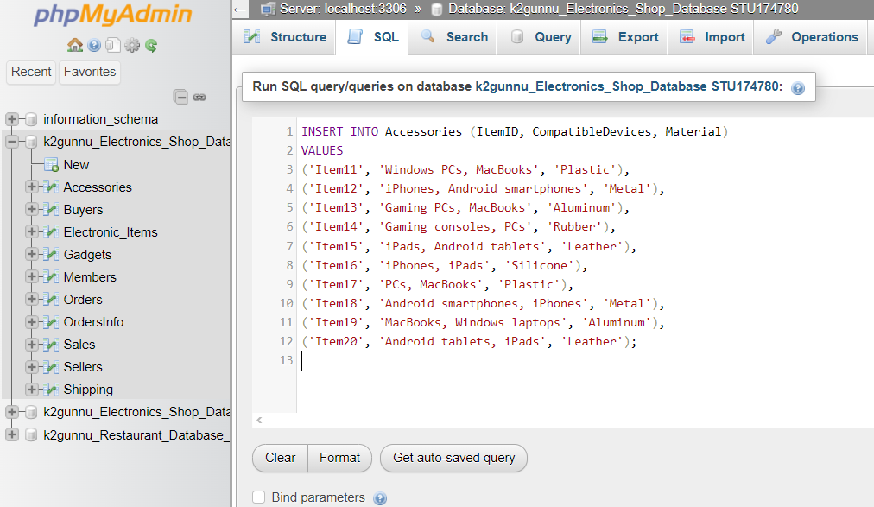

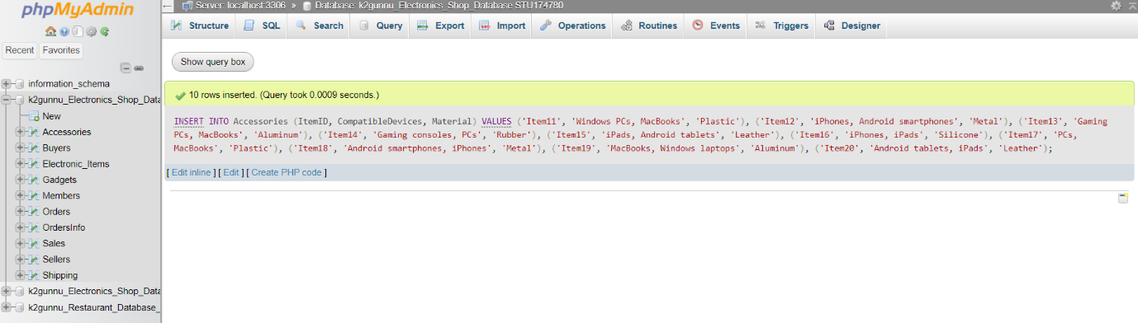

Shipping Insert:

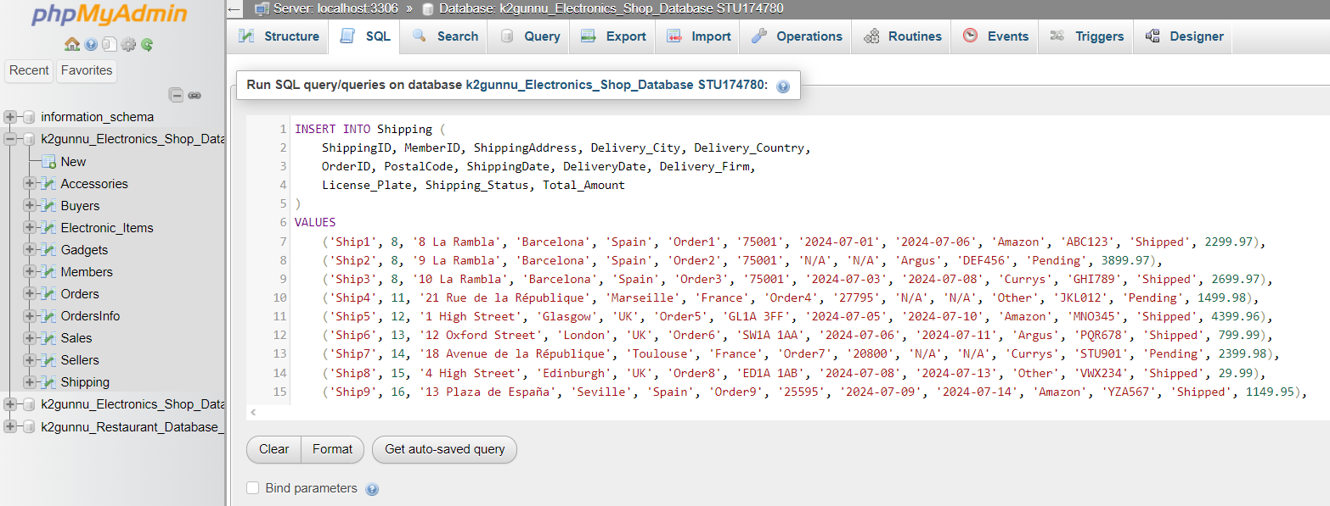

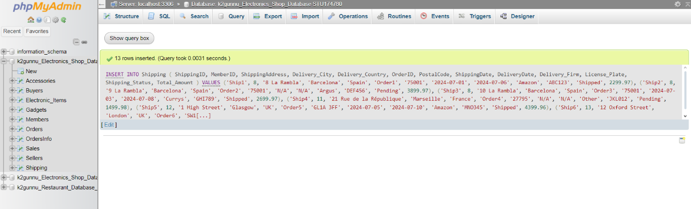

Sales Insert:

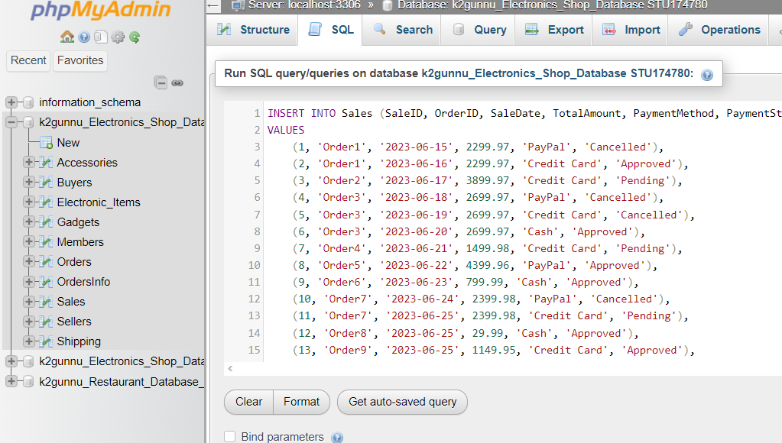

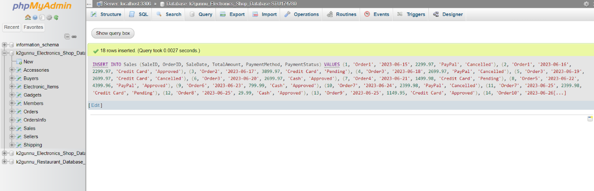

Orders Insert:

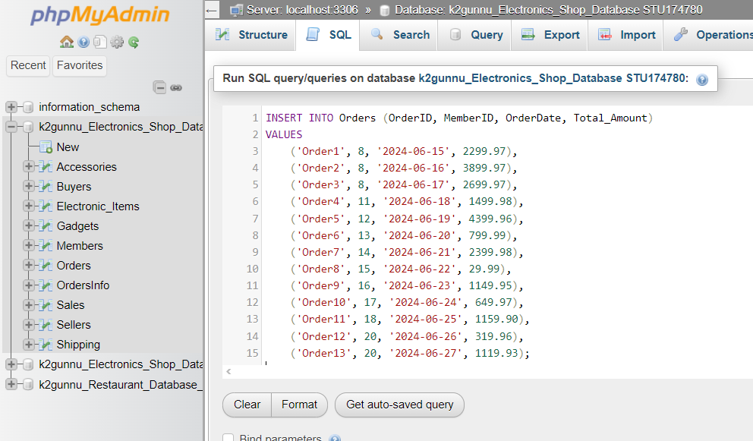

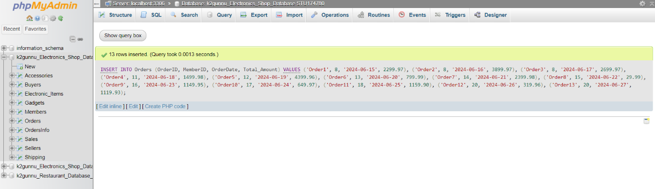

OrdersInfo Insert:

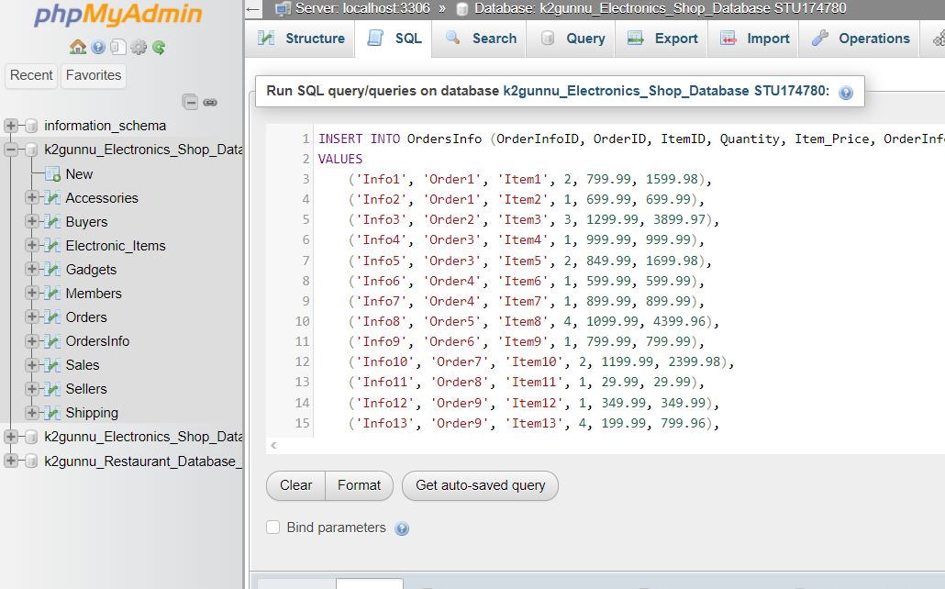

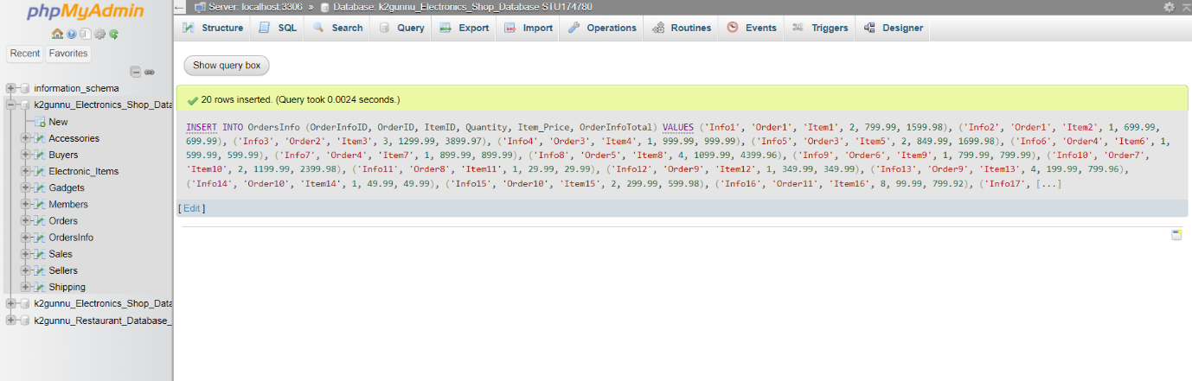

**Part IV. Constraints,De-norm data,Index and Inheritance.**

Check Constraints:

According to Gavin (2005): “Validation check— Similar to a NOT NULL constraint, a validation checking type of constraint restricts values in fields when a record is added or changed in a table.” In my database, I applied the CHECK constraint seven times to guarantee good data integrity. For instance, to make tracking and analysis of payments easier, I limited PaymentMethod to 'Credit Card,' 'PayPal,' or 'Cash.' This increased efficiency and security by revealing anomalies. Likewise, I restricted Item_Condition to 'New,' 'Used,' and 'Poor' in order to prevent confusion and guarantee logical categorization.I minimized human errors and maintained clear, logical data entries, improving overall efficiency and accuracy, by using CHECK constraints on PaymentStatus ('Approved', 'Pending', 'Cancelled'), Delivery_Firm ('Amazon', 'Argus', 'Currys', 'Other'), Shipping_Status ('Pending', 'Cancelled', 'Shipped'), MemberType ('Seller', 'Buyer'), and Item_Type ('Gadget', 'Accessory').

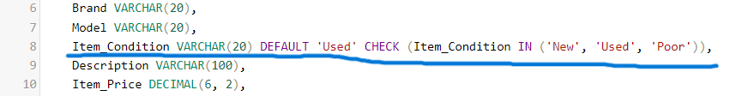

Default Constraints:

To reduce errors and boost productivity, I used the DEFAULT constraint ten times in my database. To speed up and streamline the user experience, I changed the default value of the three instances:date joined, sale date, and order date,to CURRENT_DATE, which assumes that data entry is finished on the current day. The default CHECK restrictions were applied in two cases: one where PaymentStatus was set to 'Pending' to ensure that transactions are validated and avoid issues from being accepted prematurely, and the other where the condition for items was set to 'used' to stop false advertising and enhance customer satisfaction. For four instances, I set the default values of 0 for Stock_Count, Total_Quantity_Sold, Total_Spent_Amount, and Total_Profit_Amount in order to guarantee security and efficiency. This initiates entries from scratch and avoids initial data issues.Finally, in order to prevent anomalies and preserve database integrity, I set the default quantity in OrdersInfo to 1. This ensures that orders contain at least one item. These settings improve security, simplify data entry, and preserve data quality.

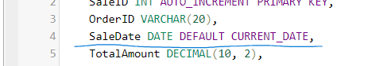

Increment Constraints:

I generated unique IDs for every new member and sale automatically by using the AUTO_INCREMENT function for both SaleID and MemberID. This guarantees that every transaction and member has a unique ID, streamlines the process of adding new entries, and lowers human entry errors. This method provides a faster and dependable database function by effectively managing references across linked tables and preserving data integrity.

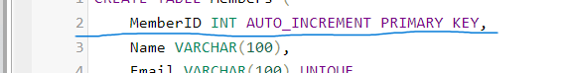

De-normalizations:

I improved efficiency and made data retrieval easier in four instances by using denormalization.According to Gavin (2005):”Too much minimization of redundancy implies too much granularity and too many tables. Too many tables can lead to extremely huge SQL join queries. The more tables in a SQL join query, the slower queries execute. Performance can be so drastically affected as to make applications completely useless.”

The frequency of table joins is decreased by storing Item_Price in ORDERINFO from Electronic_Items, Total_Amount in SHIPPING and SALES from Orders, and Name in ELECTRONIC_ITEMS from Members. In summary, this optimization enhances database performance and efficiency by accelerating searches and making data access easier for order processing, shipping, sales reporting, and item listings.

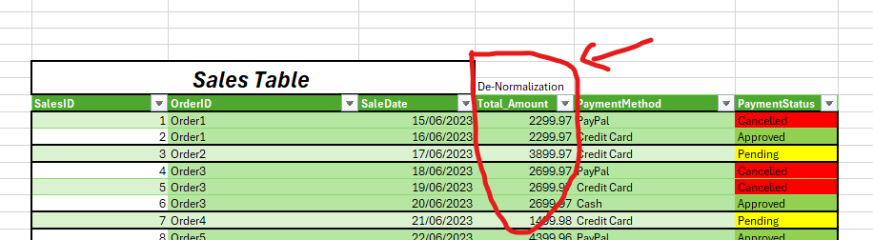

Indexes:

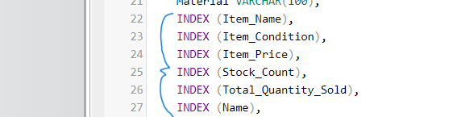In order to improve query efficiency and guarantee effective data retrieval, I employed 40 indexes over multiple tables. Indexes on columns such as Name, Email, Password, Address, Phone, MemberType, DateJoined, Total Profit Made, Total Spent Amount, Country, and RecoveryPIN in the Members table enhance user identification and reporting by improving member information searches and lookups. Queries regarding shipping logistics and tracking are accelerated in the Shipping table via indexes on Delivery_Country, ShippingDate, DeliveryDate, License_Plate, Shipping_Status, PostalCode, Delivery_City, ShippingAddress, and Delivery_Firm. Indexes on SaleDate, PaymentMethod, and PaymentStatus help the Sales table work faster during analysis and transaction validation. The Orders table simplifies financial analysis and order management with indexes on OrderDate and Total_Amount. Product searches and inventory management are improved by indexing columns in the Electronic_Items table such as Color, Brand, Model, Item_Name, Condition, Description, Item_Type, Item_Price, Specification, YearOfManufacturing, BatteryLife, OperatingSystem, Processor, CompatibleDevices, and Material. As said by Gavin (2005),when taken as a whole, these indexes enhance query performance, search effectiveness, and data retrieval speed while having a minimal negative effect on writing activity.

Inheritance:

Consulting what Jan (2016) said,in order to improve productivity and better organize data for my e-commerce website, I decided to implement inheritance in the Electronic_Items and Members tables. It was simpler to maintain product details,such as battery life for gadgets and materials for accessories,while keeping common features centralized by classifying products into Gadgets and Accessories under Electronic_Items. This method speeds up query processing and streamlines product management. Similar to this, handling tasks and particular details like spending history for buyers or sales history for sellers became clearer when Sellers and Buyers were separated from the Members table. The design supports a more efficient and scalable platform by guaranteeing data consistency and streamlining database operations.

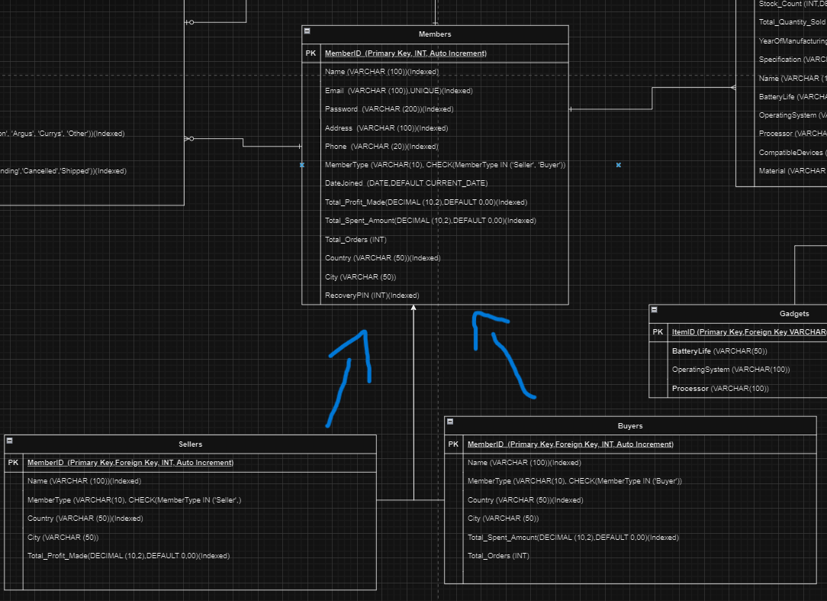

**Part V. Views,Storing Procedures and Triggers.**

Views:

SupiciousActivityTracker View

**Reason:**

As said by Thomas,Thomas and Carolyn (2015): “It provides a powerful and flexible security mechanism by hiding parts of the database from certain users. Users are not aware of the existence of any attributes or tuples that are missing from the view”.By keeping an eye on sales and cancellations, the SuspiciousActivityTrackerView aims to detect and report on unusual activity. Order totals and member information are among the relevant information that it obtains by joining the Sales, Orders, and Members tables. The cancellations by payment method and total cancellations per member are calculated for each member in the overview. It identifies members and payment methods with abnormally high cancellation rates by focusing on cancelled transactions, making it possible to spot suspicious activity that might point to fraud. This provides a thorough monitoring tool, which aids in maintaining the security and integrity of the database.

**How it works:**

Joins are used by the SuspiciousActivityTrackerView to link the Sales, Orders, and Members tables, enabling extensive information gathering. To combine data, such as the total number of cancellations per member and by payment type, grouping (GROUP BY) is utilized. Aliases (AS) makes column names easier to read. Data comparison and calculation are done with expressions. For example, COUNT(s.SaleID) counts cancellations. The outcome highlights members and payment methods with high cancellation rates, which aids in the identification of questionable activities.

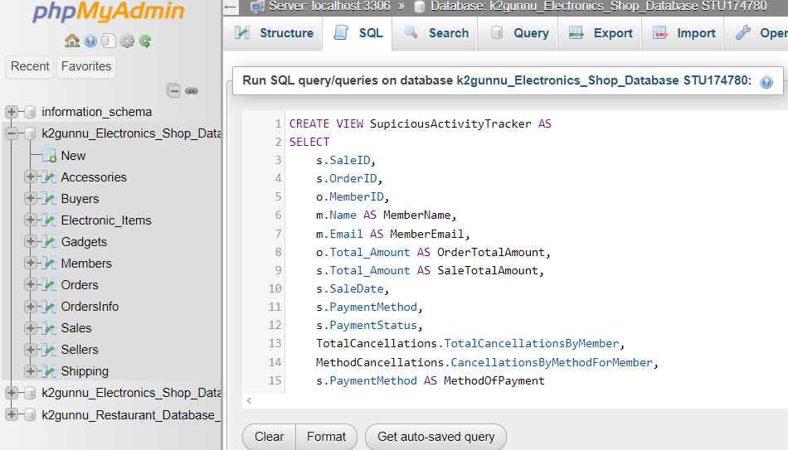

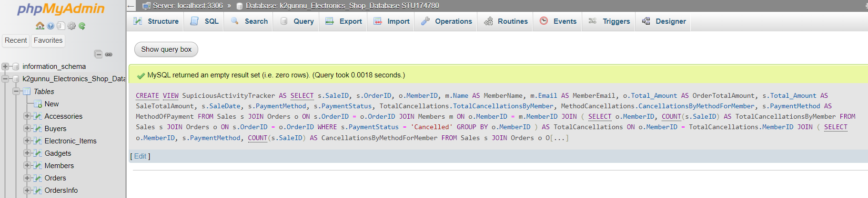

**Result:**

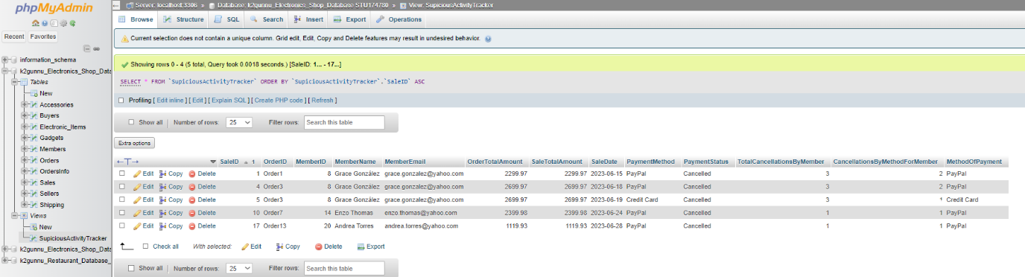

PriorityResearchItems View

**Reason:**

In the words of Thomas,Thomas and Carolyn (2015):” It permits users to access data in a way that is customized to their needs, so that the same data can be seen by different users in different ways, at the same time.” In order to focus on particular high-priority items that could need more in-depth consideration for strategic decisions, the PriorityResearchItems view is essential for targeted market study. The view enables representative and diverse sampling of data by selecting a subset of these objects at random. Informed decisions about inventory management, marketing tactics, and product development may be made with this information, as well as trends and product performance evaluation. Through a focus on major products and ensuring that the sample is representative but diverse, the methodology seeks to optimize research efforts.

**How it works:**

By combining the Electronic_Items and Members tables, the PriorityResearchItems view selects extensive data about particular electronic items (Item1, Item7, Item13, Item17, and Item 19). Along with seller details like name, country, and city, it contains item specifics like ID, name, type, brand, model, condition, price, total amount sold, and stock count. There are are just five returns and the elements are arranged randomly (ORDER BY RAND()). When performing focused market research on particular high-priority topics, this view is helpful.

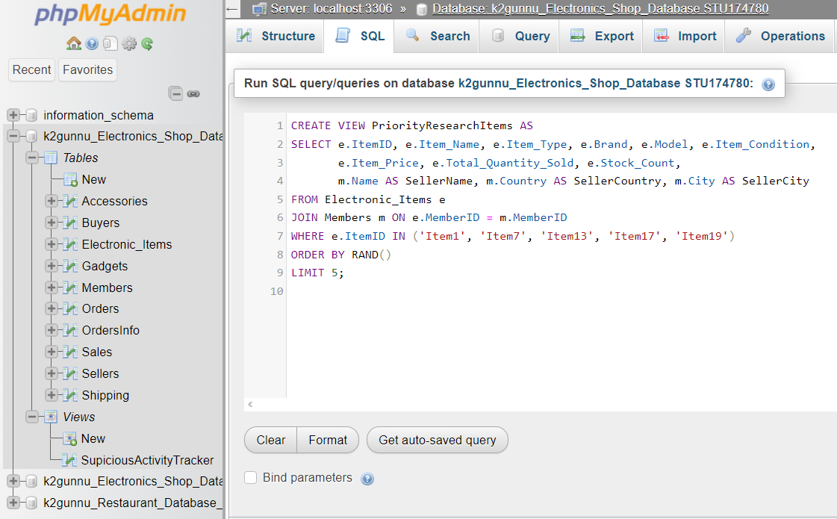

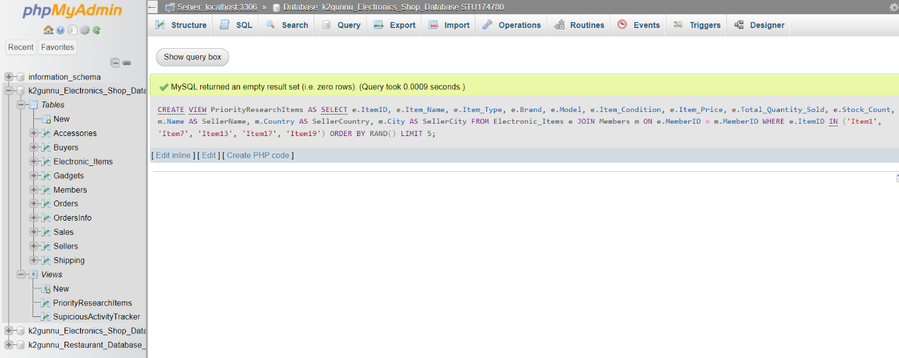

**Result:**

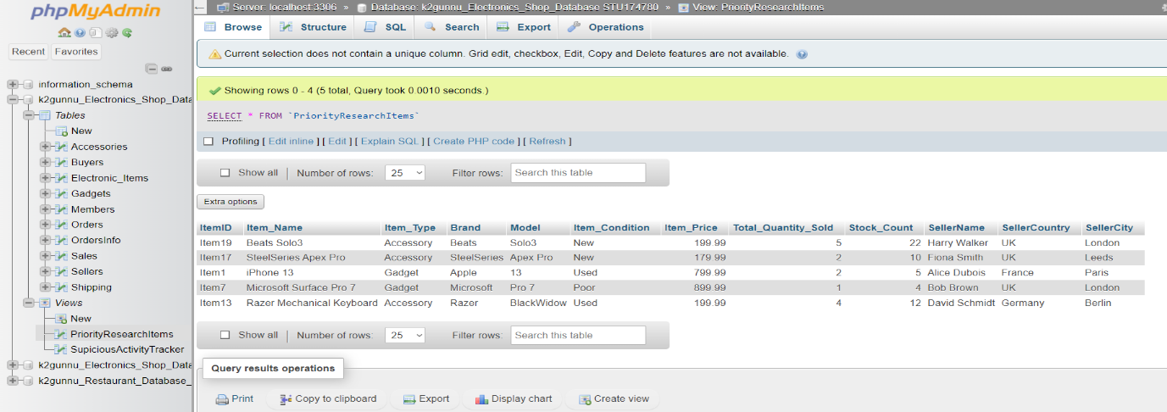

'TopBuyersAnalysis View

**Reason:**

In order to determine and rank the top purchasers, the TopBuyersAnalysis view is essential since it provides information about consumer behavior and spending trends. The company can improve customer relationship management, target promotions, and customize marketing campaigns by identifying the greatest spenders. This knowledge enhances customer retention, improves sales tactics, and increases total profitability.

**How it works:**

In the words of Gavin (2005): “A join query is a query retrieving records from more than one table. Records from different tables are usually joined on related key field values. “Joins are used in the TopBuyersAnalysis view to connect the Members and Orders tables, which makes it easier to combine buyer-related information. In order to compute metrics like TotalOrders, TotalSpent, and AvgSpentPerOrder per buyer, aggregation functions like COUNT, SUM, and AVG can be used to organize the data based on MemberID, Name, Country, and City (GROUP BY).According to Gavin (2005):” An aggregated query uses the GROUP BY clause to summarize repeating groups of records into aggregations of those groups. The following syntax adds the syntax for the GROUP BY clause”. To improve query clarity, aliases (AS) are used to alias table names (m for Members) and column names (e.g., BuyerName for m.Name). Aggregated numbers are computed using expressions like SUM(o.Total_Amount) and AVG(o.Total_Amount), which reveal information about the spending habits of customers. This method facilitates strategic decision-making and customer relationship management by identifying top purchasers based on their overall spending and average spending per order.

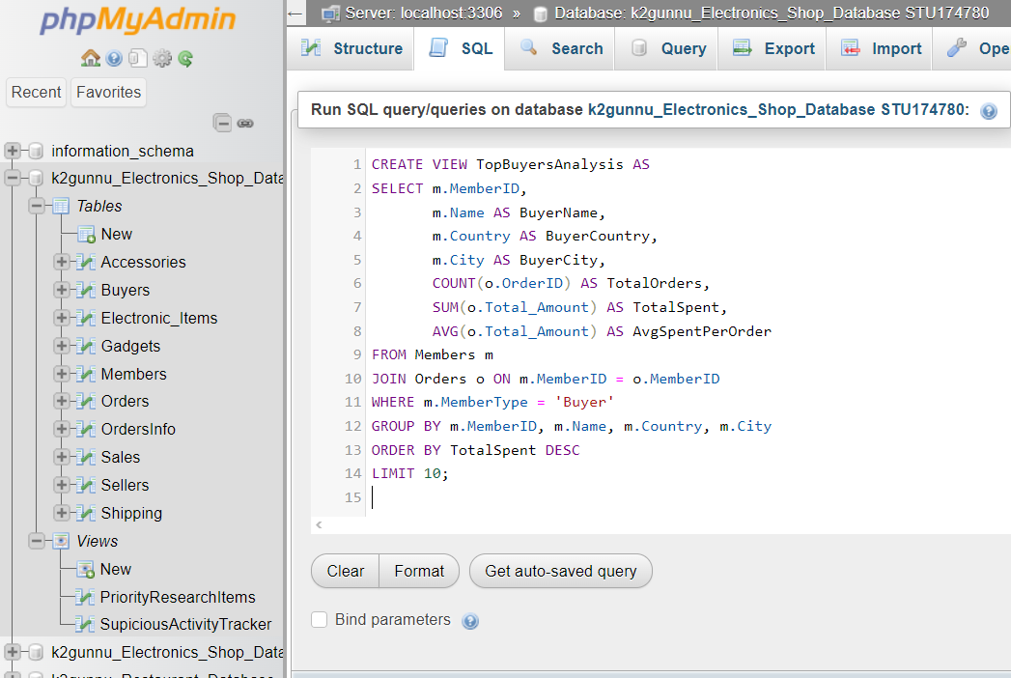

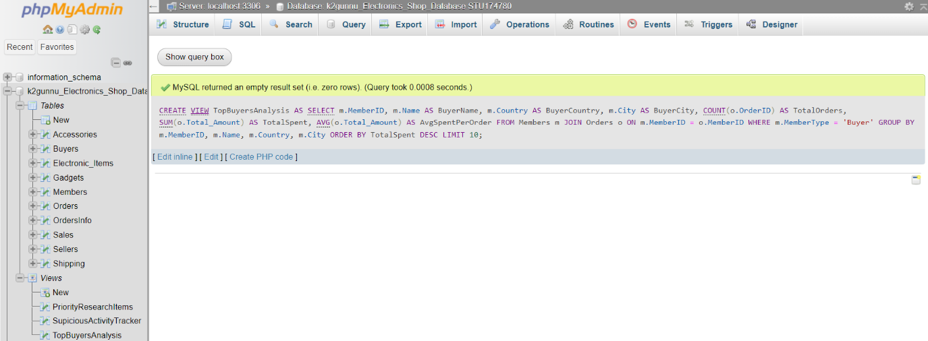

**Result:**

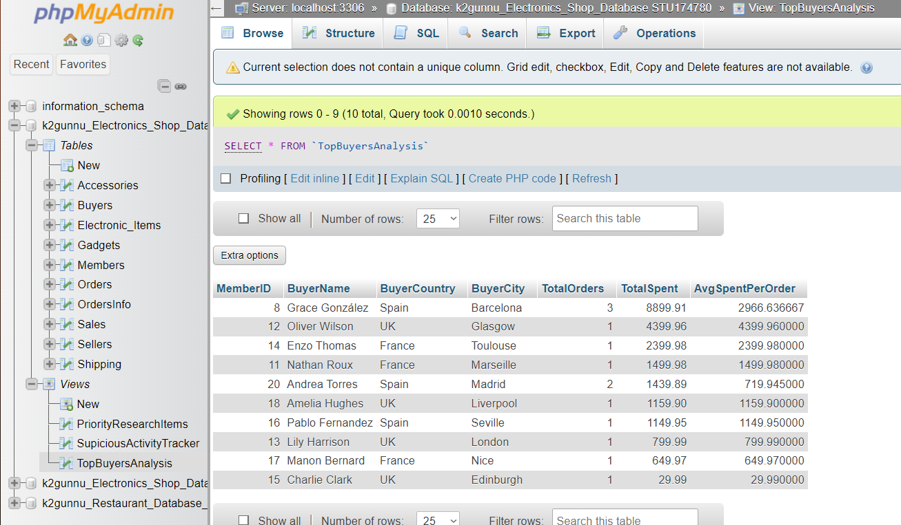

Store Procedure:

Complex procedures:

CalculateProfitDifference

**Reason:**

After removing sellers with zero or negative earnings, the CalculateProfitDifference stored function calculates the difference in profits between the sellers with the highest and lowest profits. In the context of the database, this process is crucial for financial analysis and performance evaluation. To evaluate the range of profitability among sellers who are actively making positive earnings, this process is required. It highlights both top-performing and underperforming salespeople and offers insights into the variation in financial success. Making strategic decisions, seeing areas for development, and recognizing top-performing sellers all depend on this data.

**How it works:**

The maxProfit, minProfit, and profitDifference decimal variables are declared at the start of the CalculateProfitDifference stored procedure. To determine which vendors with positive profits have the biggest and lowest profits, it runs two queries. The SET statement is used to calculate the difference between these values. Using a SELECT statement, the process finally delivers the results, displaying MaxProfit, MinProfit, and ProfitDifference. The method uses BEGIN... END for execution and is defined with DELIMITER // to accommodate multi-line procedures. It uses SET for arithmetic operations, SELECT INTO to fetch values, and DECLARE to initialize variables.

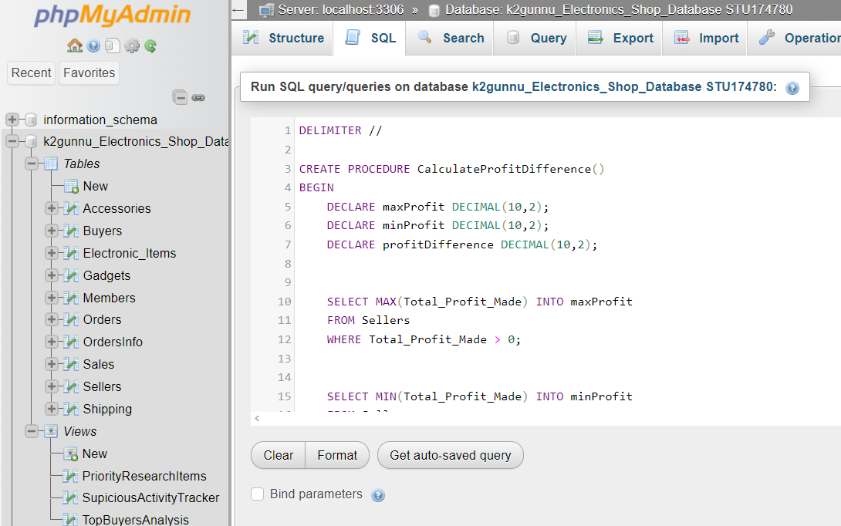

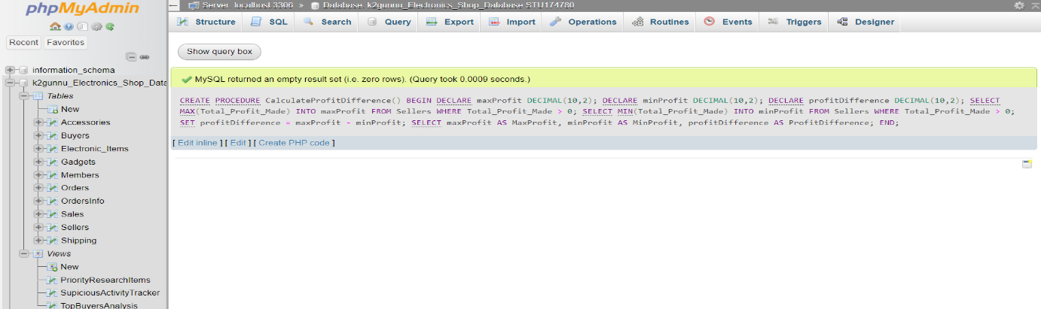

**Result:**

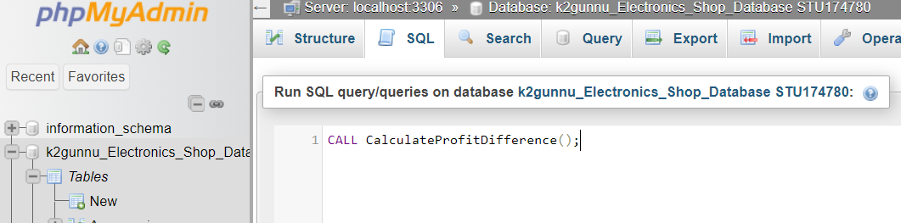

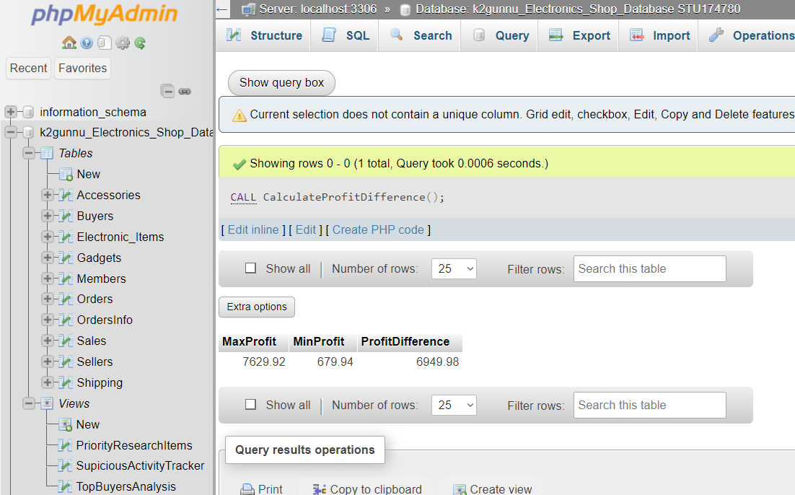

GetMemberSecurityDetails

**Reason:**

This process is necessary in order to get and present vital security data regarding a member. Ensuring data protection measures, administering account recovery procedures, and confirming member identities are just a few of the administrative and security-related responsibilities that depend on it. Through the centralization of this functionality into a stored procedure, the system preserves the organization of the code, improves security by limiting direct access to sensitive information, and guarantees consistent retrieval of member security information throughout the program.

**How it works:**

The first four variables declared are memberName, memberEmail, memberPassword, and memberRecoveryPIN; these correspond to different security information kept in the database.Based on the supplied memberID parameter, the process runs a SELECT query to retrieve these details from the Members table. The INTO clause is then used to store the retrieved values into the stated variables.Lastly, a SELECT statement that aliases the variables MemberName, MemberEmail, MemberPassword, and MemberRecoveryPIN is used by the process to return these security data.

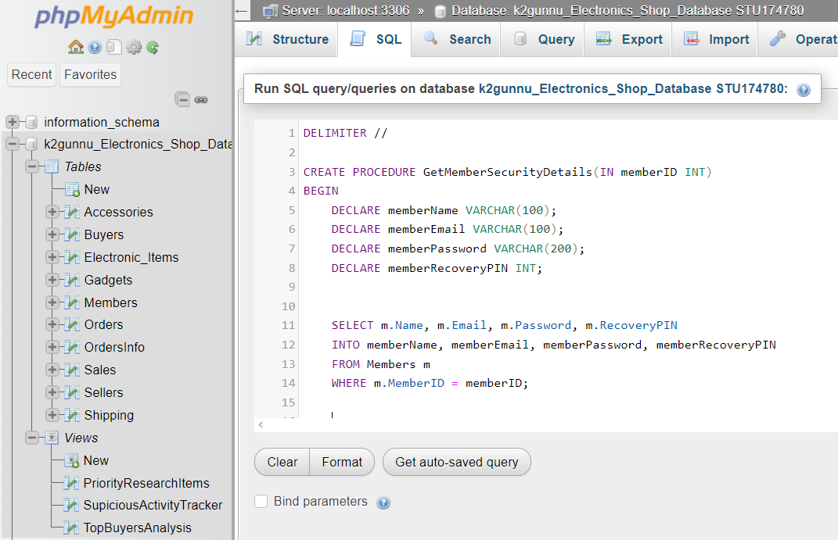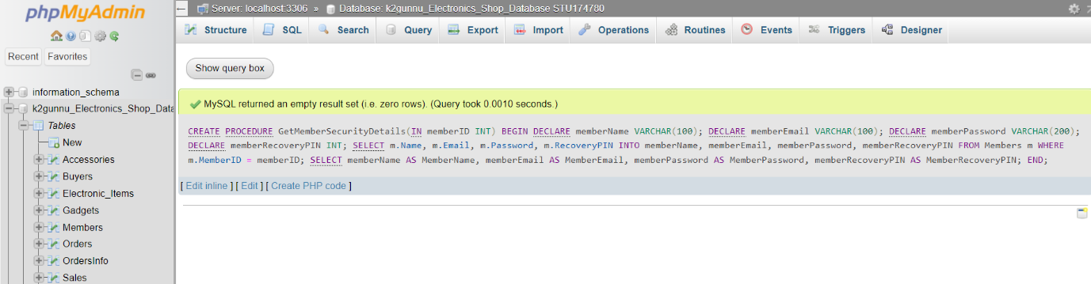

**Result:**

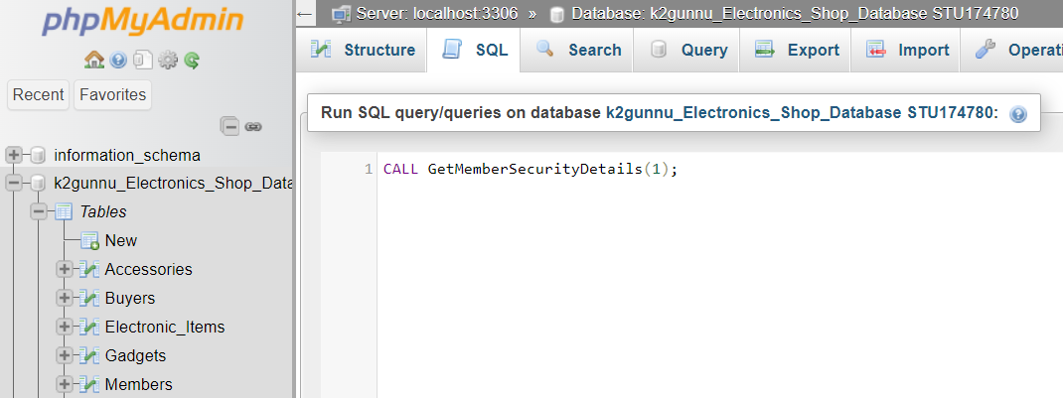

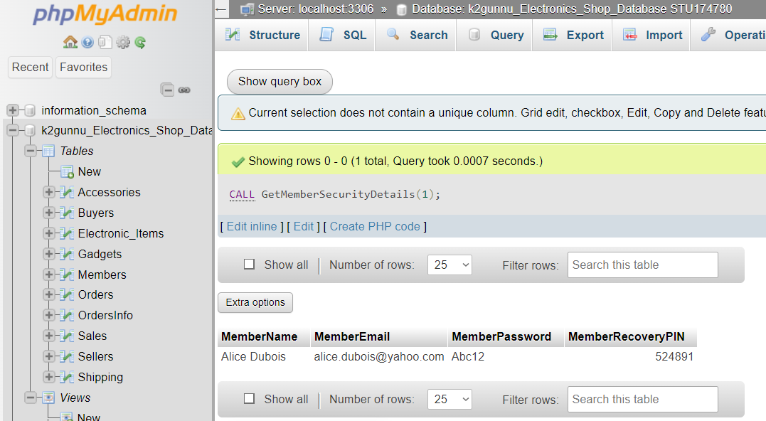

Simple procedures:

GetDeliveryPeople

**Reason:**

To extract and display delivery-related data, including license plate information, shipment and order IDs, delivery company details, and license plates, the GetDeliveryPeople technique is required. For the purposes of auditing, tracking delivery, and logistics management, this data is essential. Retrieval logic is centralized in a stored procedure, which minimizes errors and reduces the need for direct table access while guaranteeing consistency and security.

**How it works:**

Delivery information is retrieved from the Shipment table via the stored function GetDeliveryPeople. It functions as follows: In order to support multi-line procedures, it temporarily modifies the delimiter to //. It also defines the GetDeliveryPeople procedure without any input arguments and runs a SELECT query within of a BEGIN... END block to retrieve ShippingID, OrderID, License_Plate, and Delivery_Firm from the Shipping table. Lastly, the delimiter is reset to ;. This process facilitates secure and efficient access to delivery information.

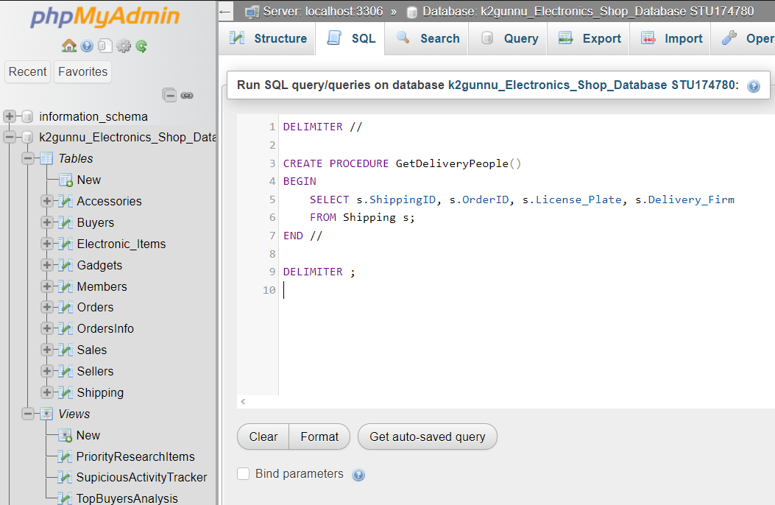

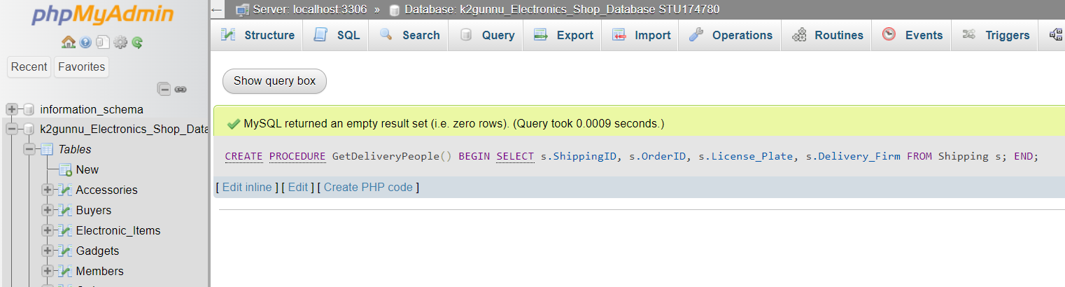

**Result:**

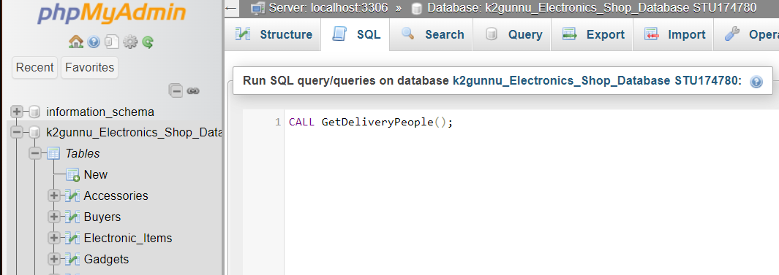

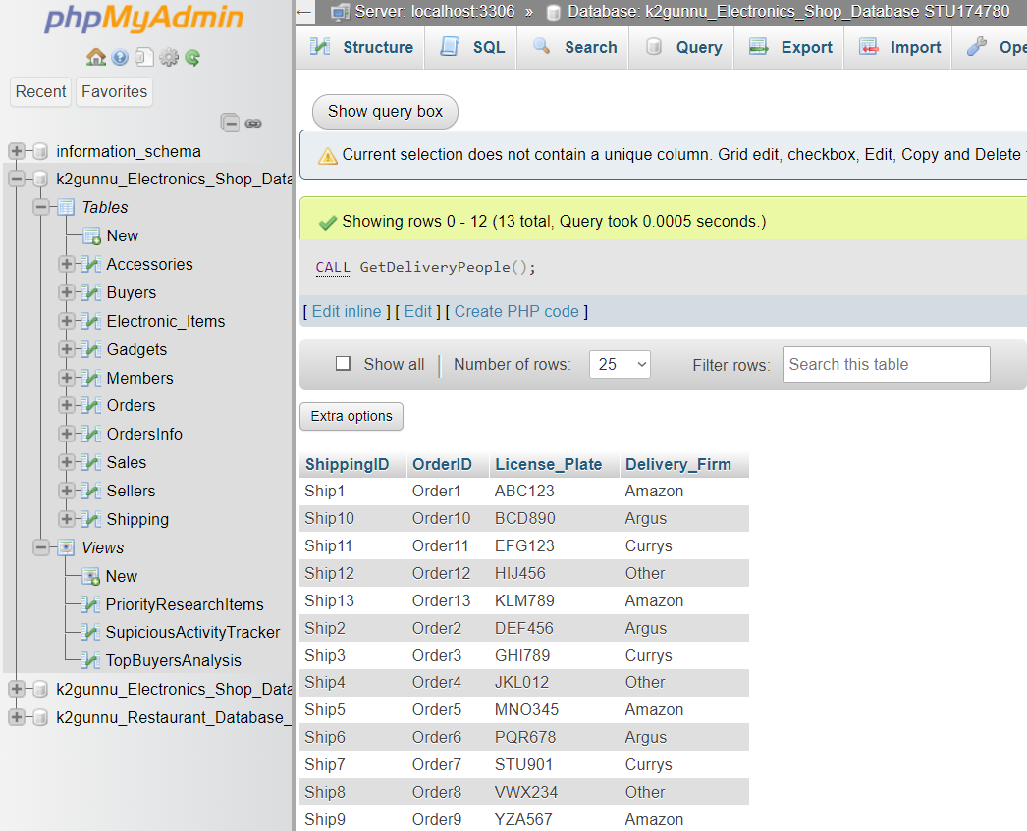

GetTop3CheapestItems

**Reason:**

Quickly determining the least expensive products is a benefit of this process, which is helpful for inventory management, clearance sales, and pricing considerations.

**How it works:** In order to handle the multi-line procedure definition, it first modifies the delimiter to //. Next, it defines the operation GetWorst3Items without specifying any input parameters. A SELECT statement is run inside the BEGIN... END block to retrieve the item_name and item_price from the Electronic_Items table. To guarantee that the least expensive products appear first, the results are arranged by Item_Price in ascending order. The results are limited to the top three least priced products by the LIMIT 3 clause. The delimiter is finally reset to ;.

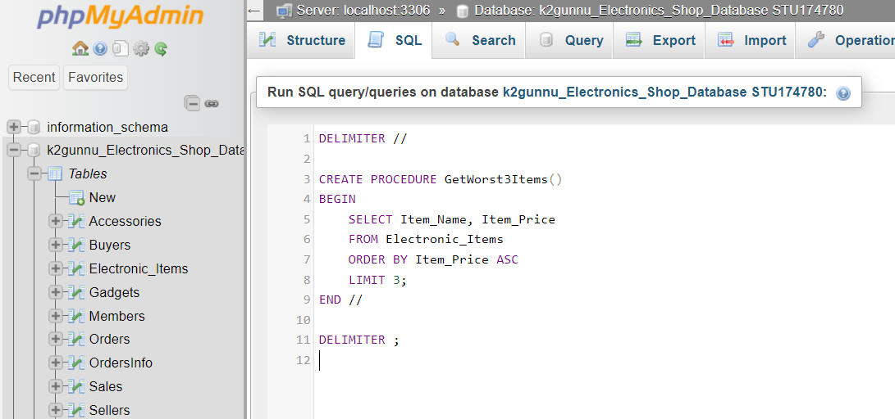

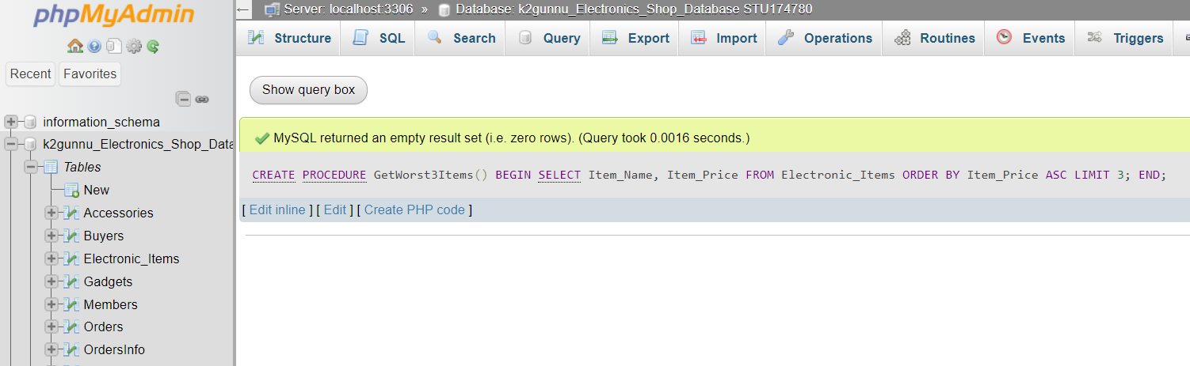

**Result:**

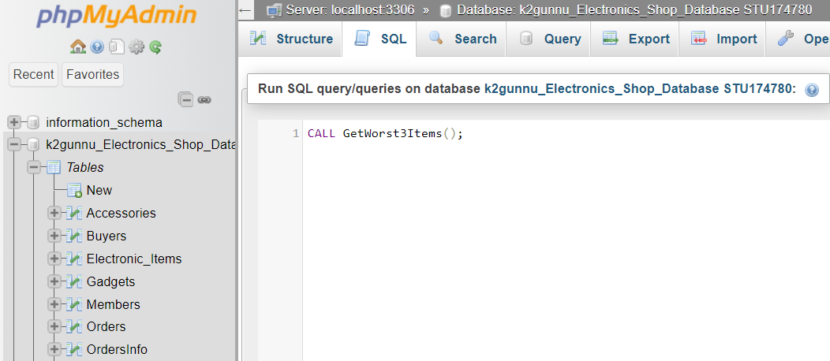

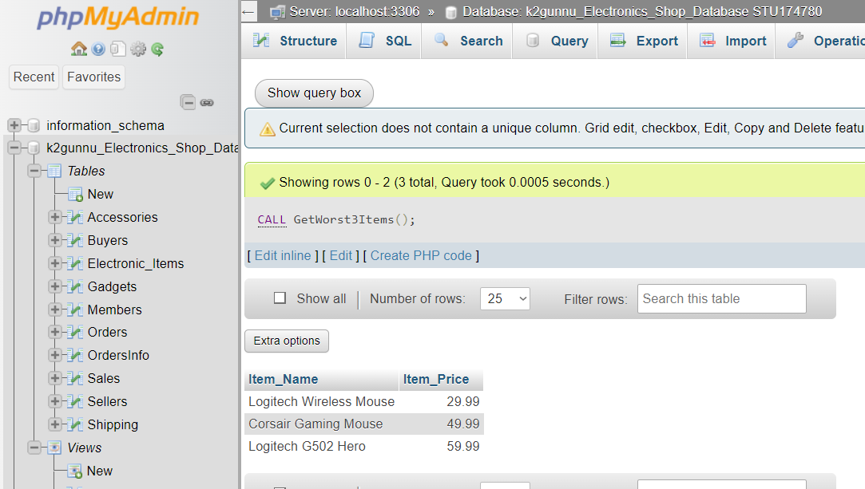

Triggers:

UpdateStockOnOrder

**Reason:**

This trigger's goal is to make sure that whenever a new order is placed, the stock numbers are updated automatically and accurately in real-time. This helps maintain accurate inventory levels, which prevents overselling and ensures better stock management.As said by Thomas,Thomas and Carolyn (2015):“Triggers can be used for a number of purposes including: maintaining audit information, by recording the changes made.”

**How it works:**

When a new row is inserted into the OrdersInfo table, the trigger is set to run. It first declares a variable called new_quantity to hold the quantity of the ordered item. Next, it uses the OrderInfoID from the newly inserted row (NEW.OrderInfoID) to fetch the quantity of the newly ordered item, which is then stored in the new_quantity variable. Finally, it updates the Stock_Count in the Electronic_Items table by deducting the quantity of the newly ordered item, utilizing the ItemID from the new order (NEW.ItemID) to determine which item's stock count to update.

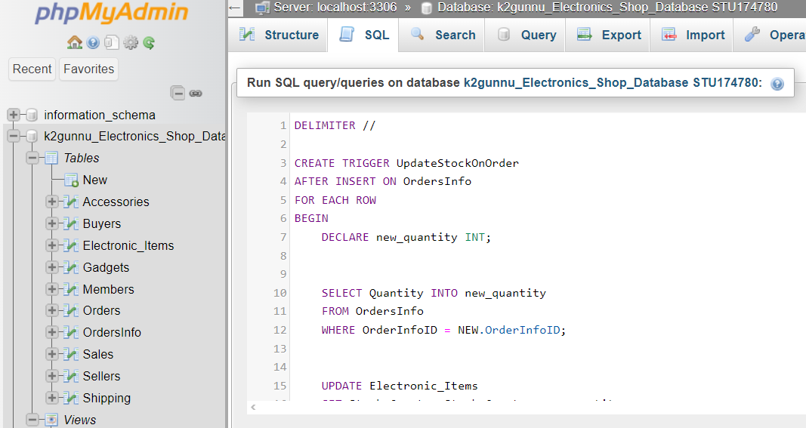

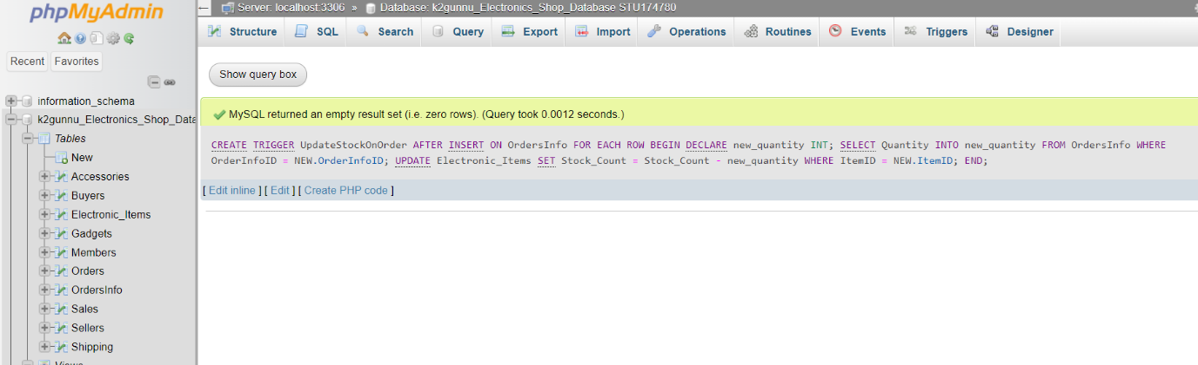

**Stock Check Before Insertion:**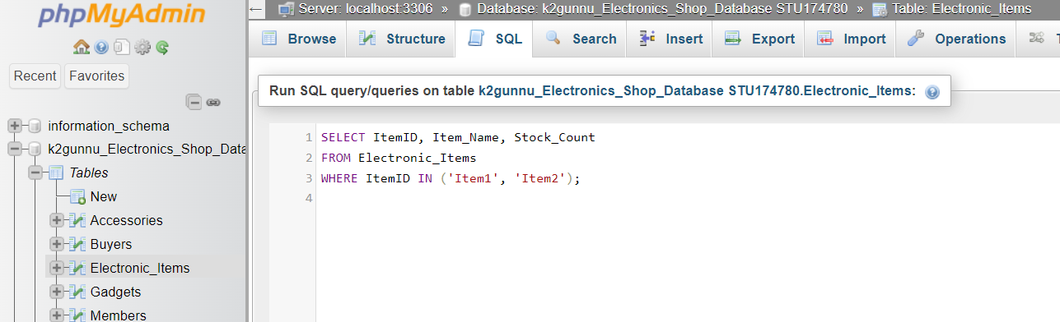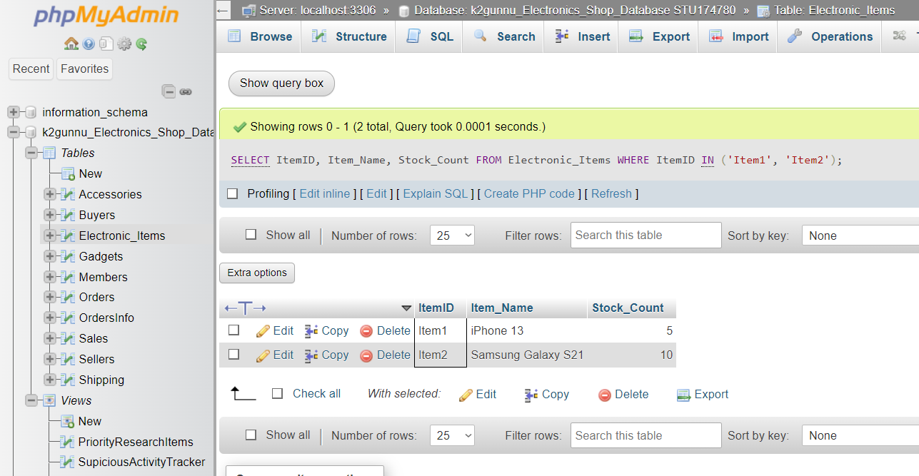

**Data Insertion:**

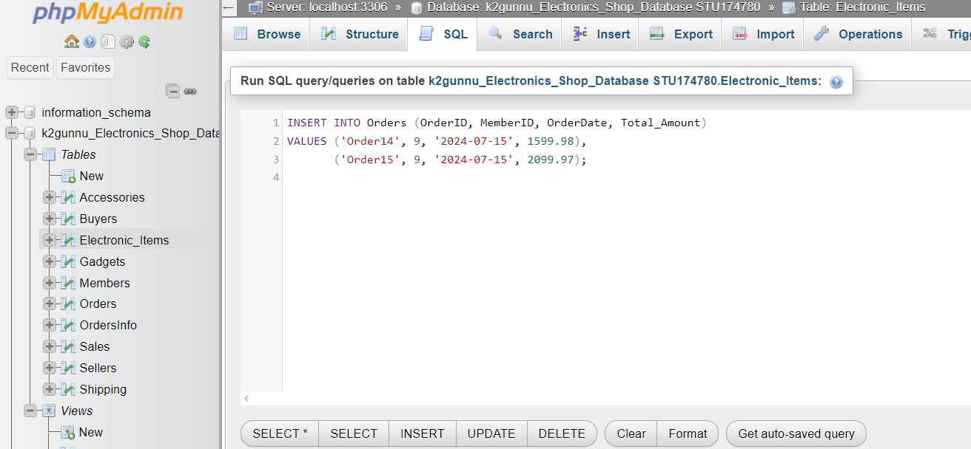

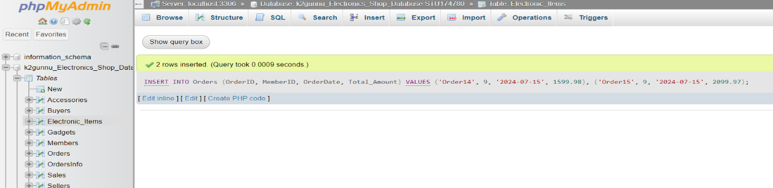

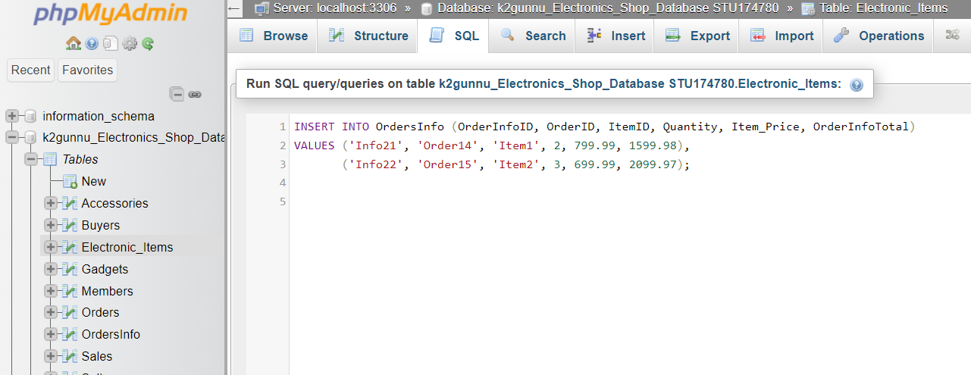

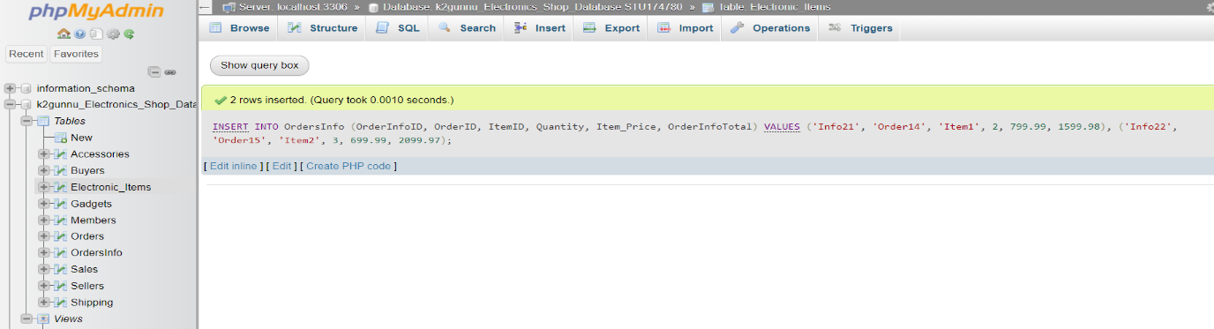

**Result, Stock Check After Insertion:**

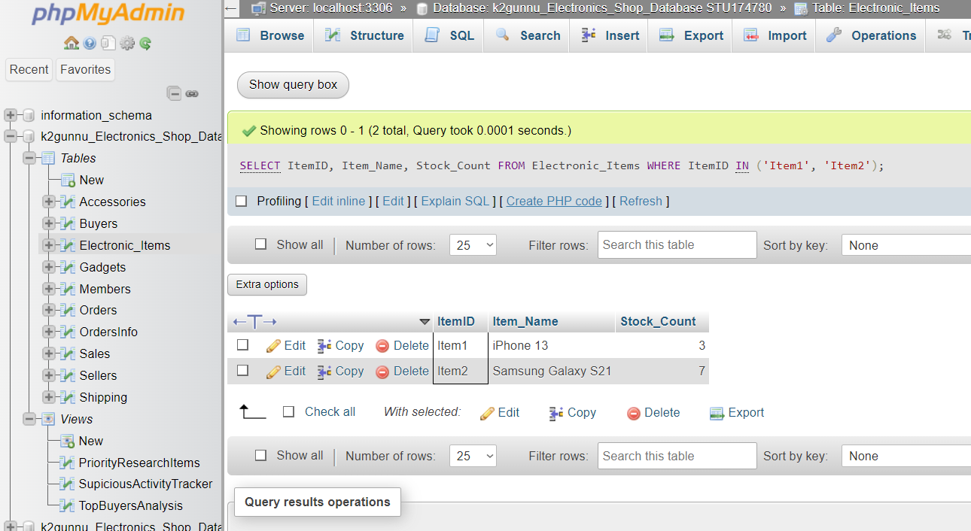

trg_audit_members

**Reason:**

This trigger's goal is to keep track of every insertion made to the Members table. For security and monitoring reasons, this aids in tracking modifications and keeping a record of data modifications.In the words of Thomas,Thomas and Carolyn (2015): “A trigger is an SQL (compound) statement that is executed automatically by the DBMS as a side effect of a modification to a named table.”

**How it works:**

Following the insertion of a new row into the Members table, the trg_audit_members trigger is activated. This trigger updates the AuditMembersTrail table with a new record whenever an insertion takes place. The name of the table where the insertion took place (Members), the action carried out (INSERT), and the current time and date (NOW()) are all included in the added record. For the purposes of security auditing, tracking historical data, and troubleshooting, the AuditMembersTrail table is intended to hold audit logs for actions taken on the Members table. It gives a record of when and what sort of data updates occurred. The four columns that make up the AuditMembersTrail table are: AuditTrailID, an auto-incrementing primary key for distinct identification; TableName, a VARCHAR(50) column holding the table name where the activity took place; Action, a VARCHAR(10) column that contains the type of action that was carried out (such as "INSERT"); and DateTime, a DATETIME column that contains the action's timestamp.

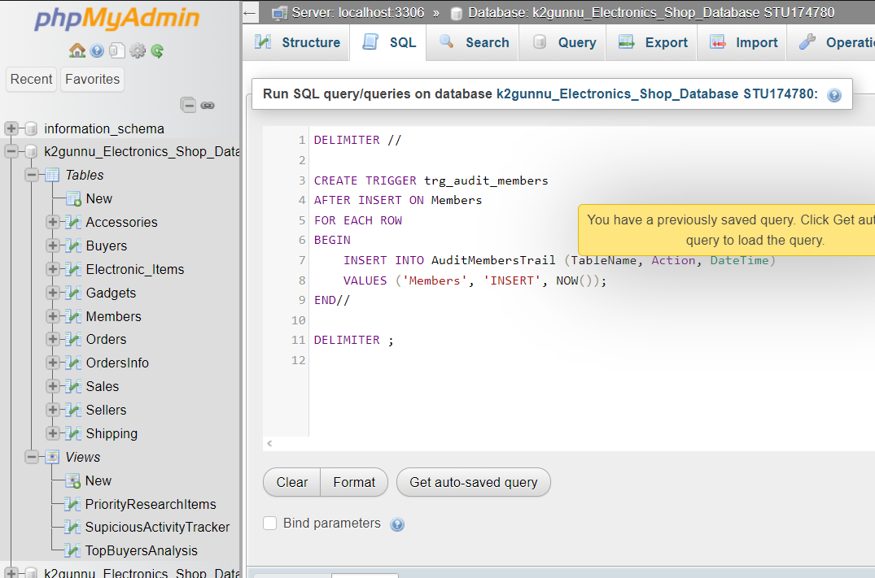

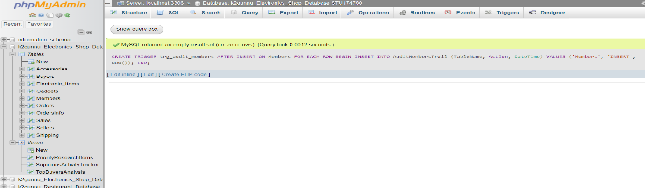

**Creating table for trigger:** 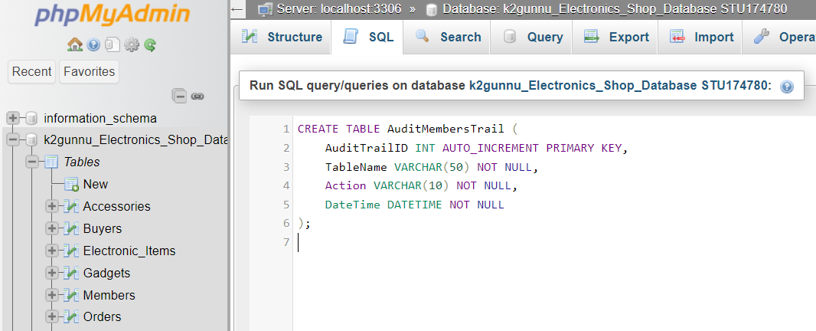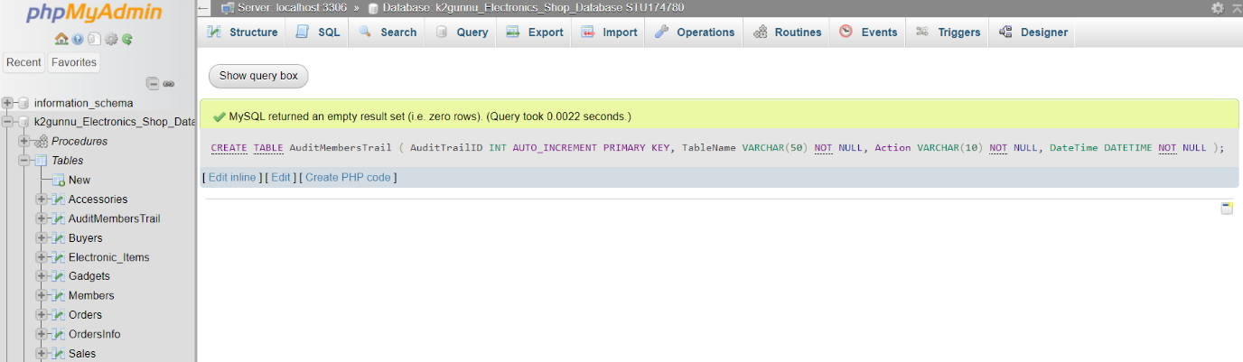

**Data Insertion:** 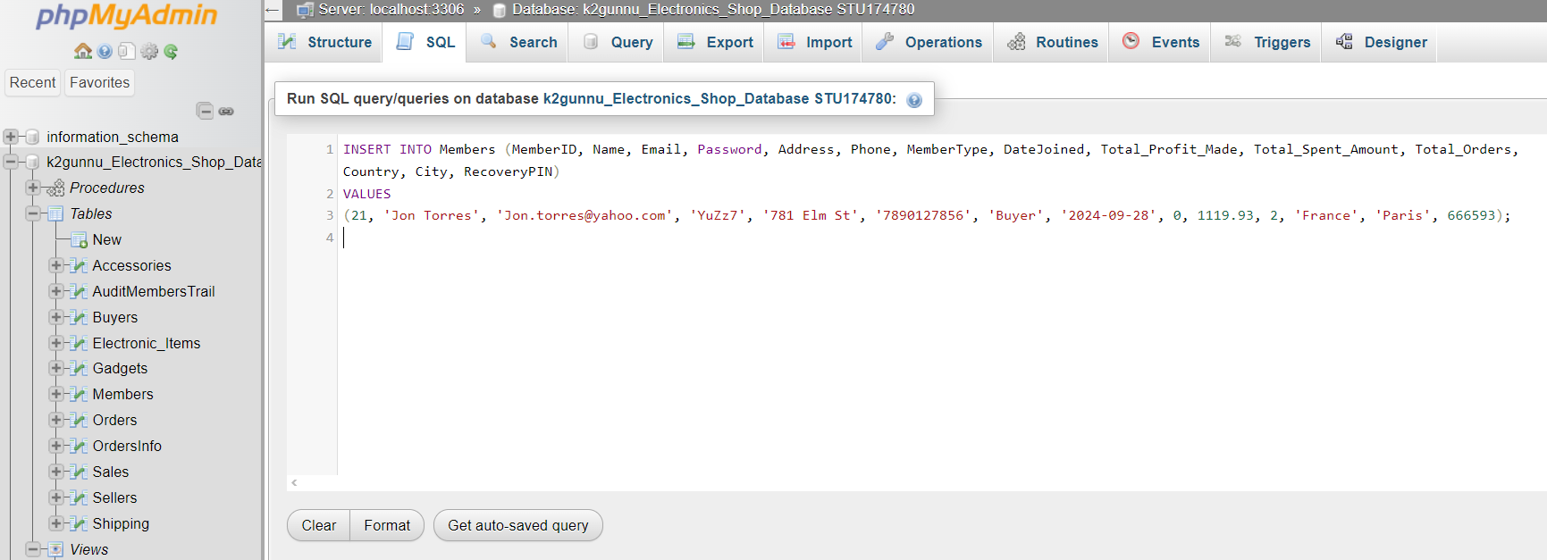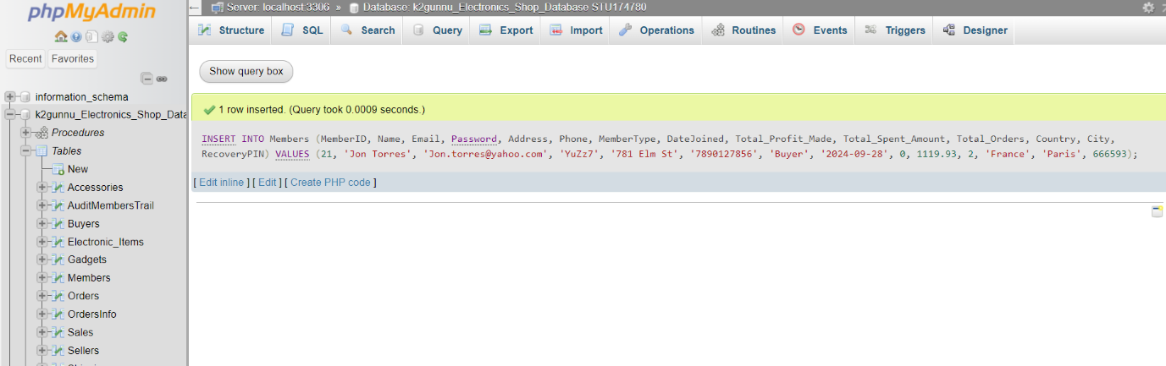

**Result:**

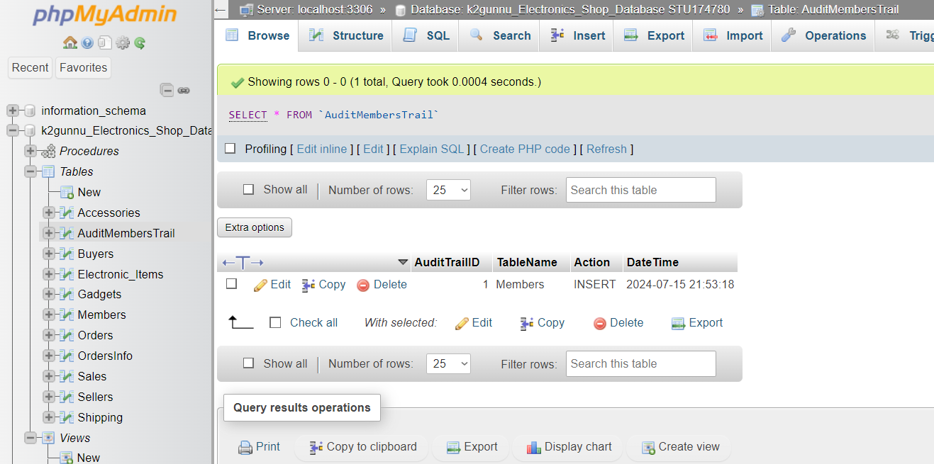

trg_audit_orders

**Reason:**The purpose of this trigger is to record each insertion made into the Orders table. This helps with tracking adjustments and maintaining a record of data modifications for security and monitoring purposes.

**How it works:**The trg_audit_orders trigger is raised when a new row is added to the Orders table. Every time an insertion occurs, this trigger adds a new record to the AuditOrdersTrail table. The new record contains the name of the table (Orders) where the insertion occurred, the action performed (INSERT), and the current date and time (NOW()). Audit logs for activities taken on the Orders table are intended to be stored in the AuditOrdersTrail table for the purposes of security auditing, tracking historical data, and troubleshooting. It provides an account of the when and what kind of data changes took place. In the AuditOrdersTrail table, there are four columns: AuditTrailID is a primary key that automatically increases for unique identification. TableName, a column with a VARCHAR(50) value containing the name of the table where the activity occurred; DateTime is a DATETIME column that carries the action's timestamp; Action is a VARCHAR(10) column that contains the kind of action that was performed (such as "INSERT").

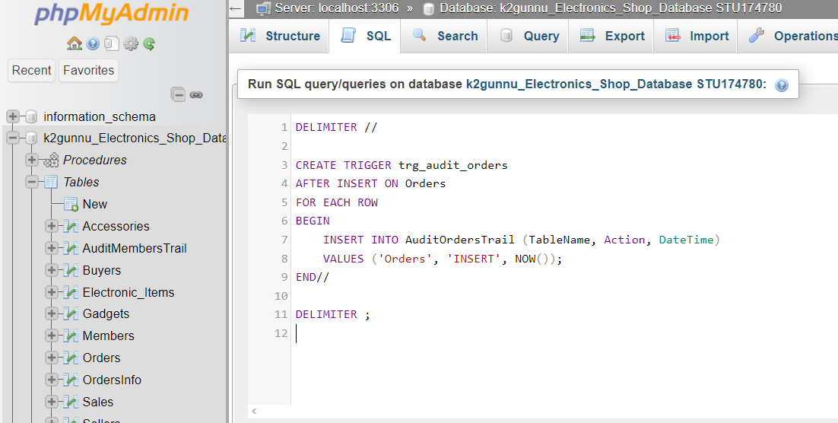

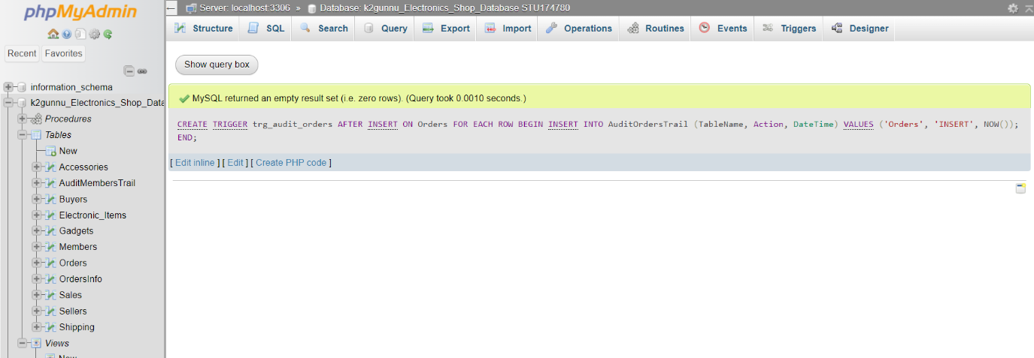

**Creating table for trigger:**

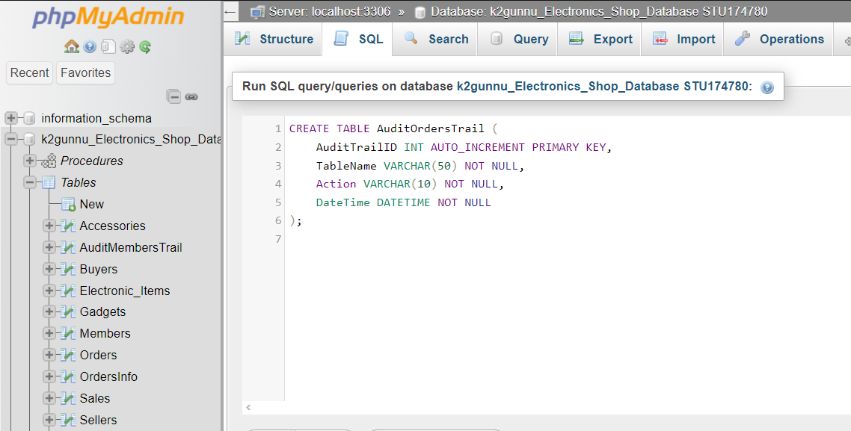

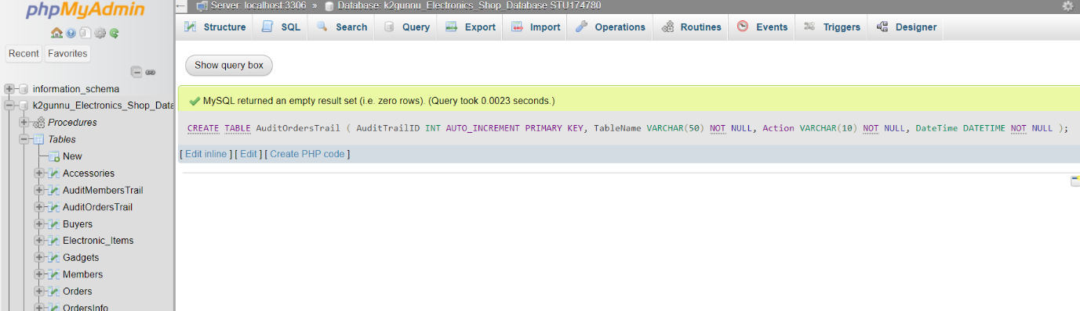

**Data Insertion:**

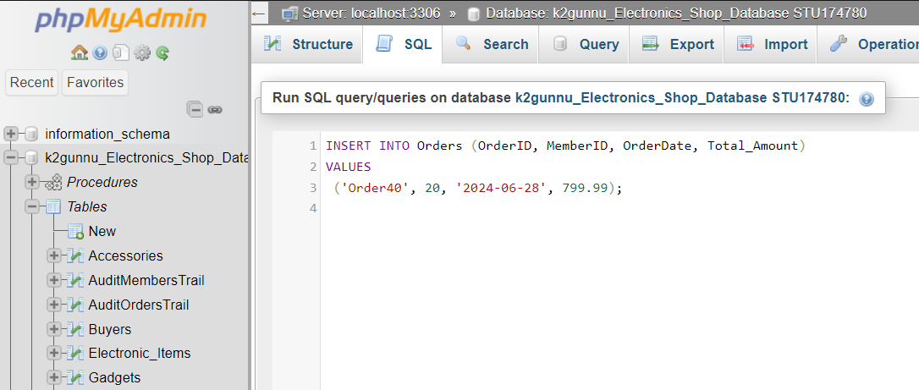

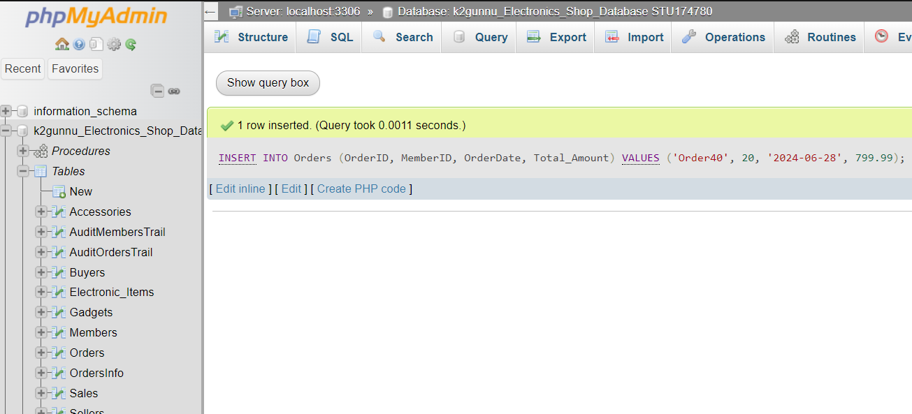

**Result:**

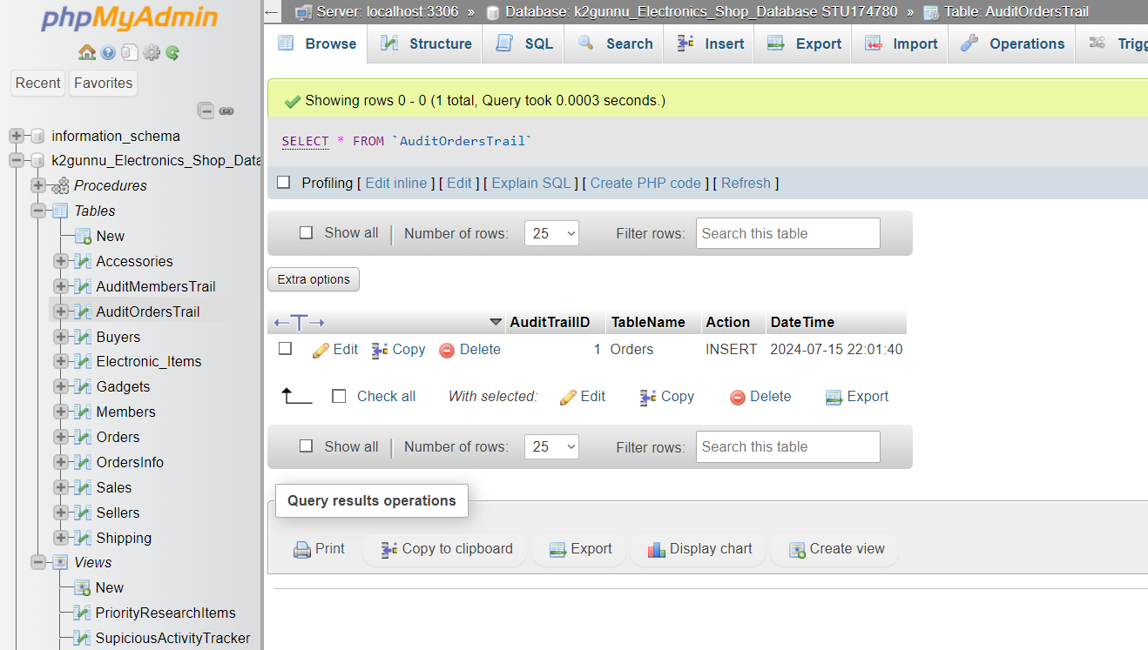

References:

Ricky, B., (2023). *Tutorials Point* [online]. Nizam: Tutorials Point. Available from:

<https://www.tutorialspoint.com/Extended-Entity-Relationship-EE-R-Model> [Accessed 15 July 2024]

Gavin, P. , (2005*). Beginning database design* [online]. Ebook edition.

Birmingham:Wrox.

Jan, L. H., (2016). *Relational Database Design and Implementation: Clearly Explained* [online]. 4th edition.

Burlington:Morgan Kaufmann.

Thomas, C., Thomas, B., Carolyn, B., (2015) *Database Systems: A Practical Approach to Design, Implementation, and Management, Global Edition* [online]. 6th edition.

London:Pearson.

Bibliography:

W3school, (2024). *SQL Tutorial* [online].

Hommersak:W3school. Available from:

<https://www.w3schools.com/sql/sql_view.asp> [Accessed 15 July 2024].

Ricky, B., (2023). *Tutorials Point* [online]. Nizam: Tutorials Point. Available from:

<https://www.tutorialspoint.com/Extended-Entity-Relationship-EE-R-Model> [Accessed 15 July 2024]

Gavin, P. , (2005*). Beginning database design* [online]. Ebook edition.

Birmingham:Wrox.

Jan, L. H., (2016). *Relational Database Design and Implementation: Clearly Explained* [online]. 4th edition.

Burlington:Morgan Kaufmann.

Thomas, C., Thomas, B., Carolyn, B., (2015) *Database Systems: A Practical Approach to Design, Implementation, and Management, Global Edition* [online]. 6th edition.

London:Pearson.

Appendix:

CREATE CODE

SALES

CREATE TABLE Sales (

SaleID INT AUTO_INCREMENT PRIMARY KEY,

OrderID VARCHAR(20),

SaleDate DATE DEFAULT CURRENT_DATE,

Total_Amount DECIMAL(10, 2),

PaymentMethod VARCHAR(20) CHECK (PaymentMethod IN ('Credit Card', 'PayPal', 'Cash')),

PaymentStatus VARCHAR(20) DEFAULT 'Pending' CHECK (PaymentStatus IN ('Approved', 'Pending', 'Cancelled')),

INDEX (SaleDate),

INDEX (TotalAmount),

INDEX (PaymentMethod),

INDEX (PaymentStatus),

FOREIGN KEY (OrderID) REFERENCES Orders(OrderID)

);

SHIPPING

CREATE TABLE Shipping (

ShippingID VARCHAR(20) PRIMARY KEY,

MemberID INT,

ShippingAddress VARCHAR(255),

Delivery_City VARCHAR(100),

Delivery_Country VARCHAR(100),

OrderID VARCHAR(20),

PostalCode VARCHAR(20),

ShippingDate VARCHAR(20),

DeliveryDate VARCHAR(20),

Delivery_Firm VARCHAR(100) CHECK (Delivery_Firm IN ('Amazon', 'Argus', 'Currys', 'Other')),

License_Plate VARCHAR(20),

Shipping_Status VARCHAR(30) CHECK (Shipping_Status IN ('Pending','Cancelled','Shipped')),

Total_Amount DECIMAL(10, 2),

INDEX (ShippingAddress),

INDEX (Delivery_Country),

INDEX (ShippingDate),

INDEX (DeliveryDate),

INDEX (Delivery_Firm),

INDEX (Shipping_Status),

INDEX (Total_Amount),

FOREIGN KEY (MemberID) REFERENCES Members(MemberID),

FOREIGN KEY (OrderID) REFERENCES Orders(OrderID)

);

ORDERS

CREATE TABLE Orders (

OrderID VARCHAR(20) PRIMARY KEY,

MemberID INT,

OrderDate DATE DEFAULT CURRENT_DATE,

Total_Amount DECIMAL(10, 2),

INDEX (OrderDate),

INDEX (Total_Amount),

FOREIGN KEY (MemberID) REFERENCES Members(MemberID)

);

ORDERSINFO

CREATE TABLE OrdersInfo (

OrderInfoID VARCHAR(20) PRIMARY KEY,

OrderID VARCHAR(20),

ItemID VARCHAR(20),

Quantity INT DEFAULT 1,

Item_Price DECIMAL(10, 2),

OrderInfoTotal DECIMAL(10, 2),

INDEX (Quantity),

INDEX (Item_Price),

FOREIGN KEY (OrderID) REFERENCES Orders(OrderID),

FOREIGN KEY (ItemID) REFERENCES Electronic_Items(ItemID)

);

MEMBERS

CREATE TABLE Members (

MemberID INT AUTO_INCREMENT PRIMARY KEY,

Name VARCHAR(100),

Email VARCHAR(100) UNIQUE,

Password VARCHAR(200),

Address VARCHAR(100),

Phone VARCHAR(20),

MemberType VARCHAR(10) CHECK (MemberType IN ('Seller', 'Buyer')),

DateJoined DATE DEFAULT CURRENT_DATE,

Total_Profit_Made DECIMAL(10, 2) DEFAULT 0.00,

Total_Spent_Amount DECIMAL(10, 2) DEFAULT 0.00,

Total_Orders INT,

Country VARCHAR(50),

City VARCHAR(50),

RecoveryPIN INT,

INDEX (Name),

INDEX (Email),

INDEX (Password),

INDEX (Address),

INDEX (Phone),

INDEX (Total_Profit_Made),

INDEX (Total_Spent_Amount),

INDEX (Country),

INDEX (RecoveryPIN)

);

BUYERS

CREATE TABLE Buyers (

MemberID INT AUTO_INCREMENT PRIMARY KEY,

Name VARCHAR(100),

MemberType VARCHAR(10) CHECK (MemberType IN ('Buyer')),

Country VARCHAR(50),

City VARCHAR(50),

Total_Spent_Amount DECIMAL(10, 2) DEFAULT 0.00,

Total_Orders INT,

INDEX (Name),

INDEX (Country),

INDEX (Total_Spent_Amount),

FOREIGN KEY (MemberID) REFERENCES Members(MemberID)

);

SELLERS

CREATE TABLE Sellers (

MemberID INT AUTO_INCREMENT PRIMARY KEY,

Name VARCHAR(100),

MemberType VARCHAR(10) CHECK (MemberType IN ('Seller')),

Country VARCHAR(50),

City VARCHAR(50),

Total_Profit_Made DECIMAL(10, 2) DEFAULT 0.00,

INDEX (Name),

INDEX (Country),

INDEX (Total_Profit_Made),

FOREIGN KEY (MemberID) REFERENCES Members(MemberID)

);

ELECTRONIC

CREATE TABLE Electronic_Items (

ItemID VARCHAR(20) PRIMARY KEY,

MemberID INT,

Item_Name VARCHAR(100),

Color VARCHAR(10),

Brand VARCHAR(20),

Model VARCHAR(20),

Item_Condition VARCHAR(20) DEFAULT 'Used' CHECK (Item_Condition IN ('New', 'Used', 'Poor')),

Description VARCHAR(100),

Item_Price DECIMAL(6, 2),

Item_Type VARCHAR(30) CHECK (Item_Type IN ('Gadget', 'Accessory')),

Stock_Count INT DEFAULT 0,

Total_Quantity_Sold INT DEFAULT 0,

YearOfManufacturing INT,

Specification VARCHAR(100),

Name VARCHAR(100),

BatteryLife VARCHAR(50),

OperatingSystem VARCHAR(100),

Processor VARCHAR(100),

CompatibleDevices VARCHAR(200),

Material VARCHAR(100),

INDEX (Item_Name),

INDEX (Item_Condition),

INDEX (Item_Price),

INDEX (Stock_Count),

INDEX (Total_Quantity_Sold),

INDEX (Name),

FOREIGN KEY (MemberID) REFERENCES Members(MemberID)

);

ACCESORIES

CREATE TABLE Accessories (

ItemID VARCHAR(20) PRIMARY KEY,

CompatibleDevices VARCHAR(200),

Material VARCHAR(100),

FOREIGN KEY (ItemID) REFERENCES Electronic_Items(ItemID)

);

GADGETS

CREATE TABLE Gadgets (

ItemID VARCHAR(20) PRIMARY KEY,

BatteryLife VARCHAR(50),

OperatingSystem VARCHAR(100),

Processor VARCHAR(100),

FOREIGN KEY (ItemID) REFERENCES Electronic_Items(ItemID)

);

INSERT CODE

Members

INSERT INTO Members (MemberID, Name, Email, Password, Address, Phone, MemberType, DateJoined, Total_Profit_Made, Total_Spent_Amount, Total_Orders, Country, City, RecoveryPIN)

VALUES

(1, 'Alice Dubois', 'alice.dubois@yahoo.com', 'Abc12', '9 Rue de la Paix', '7123456789', 'Seller', '2023-05-12', 7199.93, 0, 0, 'France', 'Paris', 524891),

(2, 'Bob Brown', 'bob.brown@gmail.com', 'XyZ34', '15 Oxford Street', '7234567890', 'Seller', '2023-06-15', 3199.96, 0, 0, 'UK', 'London', 356712),

(3, 'Carlos García', 'carlos.garcia@yahoo.com', 'Lmn56', '27 Calle de la Princesa', '7345678901', 'Seller', '2023-07-20', 7629.92, 0, 0, 'Spain', 'Madrid', 918273),

(4, 'David Schmidt', 'david.schmidt@gmail.com', 'Pqr78', '6 Unter den Linden', '7456789012', 'Seller', '2023-08-18', 1149.95, 0, 0, 'Germany', 'Berlin', 437829),

(5, 'Lucas Martin', 'lucas.martin@yahoo.com', 'StUv9', '14 Avenue des Champs-Élysées', '7567890123', 'Seller', '2023-09-10', 1449.89, 0, 0, 'France', 'Paris', 649281),

(6, 'Fiona Smith', 'fiona.smith@yahoo.com', 'ZzYy6', '3 High Street', '7678901234', 'Seller', '2024-03-18', 679.94, 0, 0, 'UK', 'Leeds', 567812),

(7, 'Harry Walker', 'harry.walker@gmail.com', 'QwEr1', '16 Oxford Street', '7789012345', 'Seller', '2023-10-05', 1119.93, 0, 0, 'UK', 'London', 182736),

(8, 'Grace González', 'grace.gonzalez@yahoo.com', 'RtY2u', '8 La Rambla', '7890123456', 'Buyer', '2023-11-03', 0, 8899.91, 3, 'Spain', 'Barcelona', 573819),

(9, 'Isabella Green', 'isabella.green@yahoo.com', 'VvWw8', '7 Reeperbahn', '7901234567', 'Buyer', '2024-05-30', 0, 0, 0, 'Germany', 'Hamburg', 475829),

(10, 'Heinrich Müller', 'heinrich.mueller@gmail.com', 'UiOp3', '5 Unter den Linden', '7890123456', 'Buyer', '2023-12-22', 0, 0, 0, 'Germany', 'Berlin', 295847),

(11, 'Nathan Roux', 'nathan.roux@yahoo.com', 'AsDf4', '21 Rue de la République', '7901234567', 'Buyer', '2024-01-14', 0, 1499.98, 1, 'France', 'Marseille', 384756),

(12, 'Oliver Wilson', 'oliver.wilson@gmail.com', 'XxYy9', '1 High Street', '7456789012', 'Buyer', '2024-06-25', 0, 4399.96, 1, 'UK', 'Glasgow', 982734),

(13, 'Lily Harrison', 'lily.harrison@gmail.com', 'GhJk5', '12 Oxford Street', '7012345678', 'Buyer', '2024-02-25', 0, 799.99, 1, 'UK', 'London', 918273),

(14, 'Enzo Thomas', 'enzo.thomas@yahoo.com', 'AaBb1', '18 Avenue de la République', '7567890123', 'Buyer', '2024-07-19', 0, 2399.98, 1, 'France', 'Toulouse', 738291),

(15, 'Charlie Clark', 'charlie.clark@gmail.com', 'CcDd2', '4 High Street', '7678901234', 'Buyer', '2024-08-14', 0, 29.99, 1, 'UK', 'Edinburgh', 183746),

(16, 'Pablo Fernandez', 'pablo.fernandez@yahoo.com', 'EeFf3', '13 Plaza de España', '7789012345', 'Buyer', '2024-09-30', 0, 1149.95, 1, 'Spain', 'Seville', 629184),

(17, 'Manon Bernard', 'manon.bernard@yahoo.com', 'IiJj5', '22 Rue de la République', '7901234567', 'Buyer', '2024-11-12', 0, 649.97, 1, 'France', 'Nice', 293847),

(18, 'Amelia Hughes', 'amelia.hughes@gmail.com', 'KkLl6', '753 Cedar Rd', '7012345678', 'Buyer', '2024-12-08', 0, 1159.9, 1, 'UK', 'Liverpool', 746392),

(19, 'Hannah Schneider', 'hannah.schneider@gmail.com', 'GgHh4', '159 Pine Ln', '7890123456', 'Buyer', '2024-10-25', 0, 0, 0, 'Germany', 'Frankfurt', 293847),

(20, 'Andrea Torres', 'andrea.torres@yahoo.com', 'ZzZz7', '789 Elm St', '7890123456', 'Buyer', '2024-09-28', 0, 1119.93, 2, 'Spain', 'Madrid', 847593);

ELECTRONIC

INSERT INTO Electronic_Items (ItemID, Name, MemberID, Item_Name, Color, Brand, Model, Item_Condition, Description, Item_Price, Item_Type, Stock_Count, Total_Quantity_Sold, Specification, YearOfManufacturing, BatteryLife, OperatingSystem, Processor, CompatibleDevices, Material)

VALUES

('Item1', 'Alice Dubois', 1, 'iPhone 13', 'Black', 'Apple', '13', 'Used', 'Latest iPhone model', 799.99, 'Gadget', 5, 2, 'Screen Size: 6.1 inch', 2023, '24 hours', 'iOS', 'Apple A15 Bionic', 'N/A', 'N/A'),

('Item2', 'Alice Dubois', 1, 'Samsung Galaxy S21', 'Silver', 'Samsung', 'S21', 'New', 'High performance phone', 699.99, 'Gadget', 10, 1, 'Screen Size: 6.2 inch', 2009, '32 hours', 'Android', 'Qualcomm Snapdragon 888', 'N/A', 'N/A'),

('Item3', 'Alice Dubois', 1, 'MacBook Pro', 'Gray', 'Apple', '2021', 'Used', 'Professional laptop', 1299.99, 'Gadget', 7, 3, 'Screen Size: 13.3 inch', 2024, '10 hours', 'macOS', 'Apple M1', 'N/A', 'N/A'),

('Item4', 'Alice Dubois', 1, 'Dell XPS 13', 'White', 'Dell', '9310', 'Poor', 'Ultra-thin laptop', 999.99, 'Gadget', 3, 1, 'Screen Size: 13.4 inch', 2012, '16 hours', 'Windows', 'Intel Core i7', 'N/A', 'N/A'),

('Item5', 'Bob Brown', 2, 'iPad Pro', 'Gold', 'Apple', '2020', 'Used', 'Powerful tablet', 849.99, 'Gadget', 6, 2, 'Screen Size: 11 inch', 2010, '12 hours', 'iPadOS', 'Apple A12Z Bionic', 'N/A', 'N/A'),

('Item6', 'Bob Brown', 2, 'Google Pixel 6', 'Black', 'Google', '6', 'New', 'Advanced smartphone', 599.99, 'Gadget', 9, 1, 'Screen Size: 6.4 inch', 2020, '20 hours', 'Android', 'Google Tensor', 'N/A', 'N/A'),

('Item7', 'Bob Brown', 2, 'Microsoft Surface Pro 7', 'Black', 'Microsoft', 'Pro 7', 'Poor', 'Versatile 2-in-1 device', 899.99, 'Gadget', 4, 1, 'Screen Size: 12.3 inch', 2002, '8 hours', 'Windows', 'Intel Core i5', 'N/A', 'N/A'),

('Item8', 'Carlos García', 3, 'Lenovo ThinkPad X1', 'Black', 'Lenovo', 'X1', 'Used', 'Business laptop', 1099.99, 'Gadget', 8, 4, 'Screen Size: 14 inch', 2008, '14 hours', 'Windows', 'Intel Core i7', 'N/A', 'N/A'),

('Item9', 'Carlos García', 3, 'Asus ROG Phone 5', 'Black', 'Asus', '5', 'New', 'Gaming smartphone', 799.99, 'Gadget', 6, 1, 'Screen Size: 6.78 inch', 2022, '16 hours', 'Android', 'Qualcomm Snapdragon 888+', 'N/A', 'N/A'),

('Item10', 'Carlos García', 3, 'Huawei MateBook X Pro', 'Silver', 'Huawei', 'X Pro', 'New', 'High-end laptop', 1199.99, 'Gadget', 5, 2, 'Screen Size: 13.9 inch', 2024, '11 hours', 'Windows', 'Intel Core i7', 'N/A', 'N/A'),

('Item11', 'Carlos García', 3, 'Logitech Wireless Mouse', 'Black', 'Logitech', 'M325', 'New', 'Comfortable wireless mouse', 29.99, 'Accessory', 20, 1, 'Wireless Connectivity', 2013, 'N/A', 'N/A', 'N/A', 'Windows PCs, MacBooks', 'Plastic'),

('Item12', 'David Schmidt', 4, 'Sony WH-1000XM4', 'Black', 'Sony', 'WH-1000XM4', 'New', 'Premium noise-cancelling headphones', 349.99, 'Accessory', 15, 1, 'Noise Cancelling', 2016, 'N/A', 'N/A', 'N/A', 'iPhones, Android smartphones', 'Metal'),

('Item13', 'David Schmidt', 4, 'Razer Mechanical Keyboard', 'Black', 'Razer', 'BlackWidow', 'Used', 'Gaming keyboard with backlighting', 199.99, 'Accessory', 12, 4, 'Mechanical Switches', 2015, 'N/A', 'N/A', 'N/A', 'Gaming PCs, MacBooks', 'Aluminum'),

('Item14', 'Lucas Martin', 5, 'Corsair Gaming Mouse', 'Black', 'Corsair', 'KATAR PRO', 'New', 'Lightweight gaming mouse', 49.99, 'Accessory', 25, 1, 'Optical Sensor', 2024, 'N/A', 'N/A', 'N/A', 'Gaming consoles, PCs', 'Rubber'),

('Item15', 'Lucas Martin', 5, 'Bose QuietComfort 35 II', 'Silver', 'Bose', 'QC35 II', 'Poor', 'Wireless Bluetooth headphones', 299.99, 'Accessory', 18, 2, 'Wireless Bluetooth', 2012, 'N/A', 'N/A', 'N/A', 'iPads, Android tablets', 'Leather'),

('Item16', 'Lucas Martin', 5, 'HyperX Cloud II', 'Red', 'HyperX', 'Cloud II', 'New', 'Comfortable gaming headphones', 99.99, 'Accessory', 20, 8, 'Surround Sound', 2010, 'N/A', 'N/A', 'N/A', 'iPhones, iPads', 'Silicone'),

('Item17', 'Fiona Smith', 6, 'SteelSeries Apex Pro', 'Black', 'SteelSeries', 'Apex Pro', 'New', 'Professional gaming keyboard', 179.99, 'Accessory', 10, 2, 'Adjustable Switches', 2008, 'N/A', 'N/A', 'N/A', 'PCs, MacBooks', 'Plastic'),

('Item18', 'Fiona Smith', 6, 'Apple Magic Mouse', 'White', 'Apple', 'A1296', 'Used', 'Sleek wireless mouse', 79.99, 'Accessory', 15, 4, 'Multi-Touch Surface', 2007, 'N/A', 'N/A', 'N/A', 'Android smartphones, iPhones', 'Metal'),

('Item19', 'Harry Walker', 7, 'Beats Solo3', 'Black', 'Beats', 'Solo3', 'New', 'On-ear wireless headphones', 199.99, 'Accessory', 22, 5, 'Wireless Headphones', 2005, 'N/A', 'N/A', 'N/A', 'MacBooks, Windows laptops', 'Aluminum'),

('Item20', 'Harry Walker', 7, 'Logitech G502 Hero', 'Black', 'Logitech', 'G502 Hero', 'Poor', 'High-performance gaming mouse', 59.99, 'Accessory', 18, 2, 'High-Precision Sensor', 2018, 'N/A', 'N/A', 'N/A', 'Android tablets, iPads', 'Leather');

SELLERS

INSERT INTO Sellers (MemberID, Name, MemberType, Country, City, Total_Profit_Made)

VALUES

(1, 'Alice Dubois', 'Seller', 'France', 'Paris', 7199.93),

(2, 'Bob Brown', 'Seller', 'UK', 'London', 3199.96),

(3, 'Carlos García', 'Seller', 'Spain', 'Madrid', 7629.92),

(4, 'David Schmidt', 'Seller', 'Germany', 'Berlin', 1149.95),

(5, 'Lucas Martin', 'Seller', 'France', 'Paris', 1449.89),

(6, 'Fiona Smith', 'Seller', 'UK', 'Leeds', 679.94),

(7, 'Harry Walker', 'Seller', 'UK', 'London', 1119.93);

BUYERS

INSERT INTO Buyers (MemberID, Name, MemberType, Country, City, Total_Spent_Amount, Total_Orders)

VALUES

(8, 'Grace González', 'Buyer', 'Spain', 'Barcelona', 8899.91, 3),

(9, 'Isabella Green', 'Buyer', 'Germany', 'Hamburg', 0, 0),

(10, 'Heinrich Müller', 'Buyer', 'Germany', 'Berlin', 0, 0),

(11, 'Nathan Roux', 'Buyer', 'France', 'Marseille', 1499.98, 1),

(12, 'Oliver Wilson', 'Buyer', 'UK', 'Glasgow', 4399.96, 1),

(13, 'Lily Harrison', 'Buyer', 'UK', 'London', 799.99, 1),

(14, 'Enzo Thomas', 'Buyer', 'France', 'Toulouse', 2399.98, 1),

(15, 'Charlie Clark', 'Buyer', 'UK', 'Edinburgh', 29.99, 1),

(16, 'Pablo Fernandez', 'Buyer', 'Spain', 'Seville', 1149.95, 1),

(17, 'Manon Bernard', 'Buyer', 'France', 'Nice', 649.97, 1),

(18, 'Amelia Hughes', 'Buyer', 'UK', 'Liverpool', 1159.9, 1),

(19, 'Hannah Schneider', 'Buyer', 'Germany', 'Frankfurt', 0, 0),

(20, 'Andrea Torres', 'Buyer', 'Spain', 'Madrid', 1119.93, 2);

ACCESSORIES

INSERT INTO Accessories (ItemID, CompatibleDevices, Material)

VALUES

('Item11', 'Windows PCs, MacBooks', 'Plastic'),

('Item12', 'iPhones, Android smartphones', 'Metal'),

('Item13', 'Gaming PCs, MacBooks', 'Aluminum'),

('Item14', 'Gaming consoles, PCs', 'Rubber'),

('Item15', 'iPads, Android tablets', 'Leather'),

('Item16', 'iPhones, iPads', 'Silicone'),

('Item17', 'PCs, MacBooks', 'Plastic'),

('Item18', 'Android smartphones, iPhones', 'Metal'),

('Item19', 'MacBooks, Windows laptops', 'Aluminum'),

('Item20', 'Android tablets, iPads', 'Leather');

GADGETS

INSERT INTO Gadgets (ItemID, BatteryLife, OperatingSystem, Processor)

VALUES

('Item1', '24 hours', 'iOS', 'Apple A15 Bionic'),

('Item2', '32 hours', 'Android', 'Qualcomm Snapdragon 888'),

('Item3', '10 hours', 'macOS', 'Apple M1'),

('Item4', '16 hours', 'Windows', 'Intel Core i7'),

('Item5', '12 hours', 'iPadOS', 'Apple A12Z Bionic'),

('Item6', '20 hours', 'Android', 'Google Tensor'),

('Item7', '8 hours', 'Windows', 'Intel Core i5'),

('Item8', '14 hours', 'Windows', 'Intel Core i7'),

('Item9', '16 hours', 'Android', 'Qualcomm Snapdragon 888+'),

('Item10', '11 hours', 'Windows', 'Intel Core i7');

ORDERS

INSERT INTO Orders (OrderID, MemberID, OrderDate, Total_Amount)

VALUES

('Order1', 8, '2024-06-15', 2299.97),

('Order2', 8, '2024-06-16', 3899.97),

('Order3', 8, '2024-06-17', 2699.97),

('Order4', 11, '2024-06-18', 1499.98),

('Order5', 12, '2024-06-19', 4399.96),

('Order6', 13, '2024-06-20', 799.99),

('Order7', 14, '2024-06-21', 2399.98),

('Order8', 15, '2024-06-22', 29.99),

('Order9', 16, '2024-06-23', 1149.95),

('Order10', 17, '2024-06-24', 649.97),

('Order11', 18, '2024-06-25', 1159.90),

('Order12', 20, '2024-06-26', 319.96),

('Order13', 20, '2024-06-27', 1119.93);

ORDERSINFO

INSERT INTO OrdersInfo (OrderInfoID, OrderID, ItemID, Quantity, Item_Price, OrderInfoTotal)

VALUES

('Info1', 'Order1', 'Item1', 2, 799.99, 1599.98),

('Info2', 'Order1', 'Item2', 1, 699.99, 699.99),

('Info3', 'Order2', 'Item3', 3, 1299.99, 3899.97),

('Info4', 'Order3', 'Item4', 1, 999.99, 999.99),

('Info5', 'Order3', 'Item5', 2, 849.99, 1699.98),

('Info6', 'Order4', 'Item6', 1, 599.99, 599.99),

('Info7', 'Order4', 'Item7', 1, 899.99, 899.99),

('Info8', 'Order5', 'Item8', 4, 1099.99, 4399.96),

('Info9', 'Order6', 'Item9', 1, 799.99, 799.99),

('Info10', 'Order7', 'Item10', 2, 1199.99, 2399.98),

('Info11', 'Order8', 'Item11', 1, 29.99, 29.99),

('Info12', 'Order9', 'Item12', 1, 349.99, 349.99),

('Info13', 'Order9', 'Item13', 4, 199.99, 799.96),

('Info14', 'Order10', 'Item14', 1, 49.99, 49.99),

('Info15', 'Order10', 'Item15', 2, 299.99, 599.98),

('Info16', 'Order11', 'Item16', 8, 99.99, 799.92),

('Info17', 'Order11', 'Item17', 2, 179.99, 359.98),

('Info18', 'Order12', 'Item18', 4, 79.99, 319.96),

('Info19', 'Order13', 'Item19', 5, 199.99, 999.95),

('Info20', 'Order13', 'Item20', 2, 59.99, 119.98);

SALES

INSERT INTO Sales (SaleID, OrderID, SaleDate, TotalAmount, PaymentMethod, PaymentStatus)

VALUES

(1, 'Order1', '2023-06-15', 2299.97, 'PayPal', 'Cancelled'),

(2, 'Order1', '2023-06-16', 2299.97, 'Credit Card', 'Approved'),

(3, 'Order2', '2023-06-17', 3899.97, 'Credit Card', 'Pending'),

(4, 'Order3', '2023-06-18', 2699.97, 'PayPal', 'Cancelled'),

(5, 'Order3', '2023-06-19', 2699.97, 'Credit Card', 'Cancelled'),

(6, 'Order3', '2023-06-20', 2699.97, 'Cash', 'Approved'),

(7, 'Order4', '2023-06-21', 1499.98, 'Credit Card', 'Pending'),

(8, 'Order5', '2023-06-22', 4399.96, 'PayPal', 'Approved'),

(9, 'Order6', '2023-06-23', 799.99, 'Cash', 'Approved'),

(10, 'Order7', '2023-06-24', 2399.98, 'PayPal', 'Cancelled'),

(11, 'Order7', '2023-06-25', 2399.98, 'Credit Card', 'Pending'),

(12, 'Order8', '2023-06-25', 29.99, 'Cash', 'Approved'),

(13, 'Order9', '2023-06-25', 1149.95, 'Credit Card', 'Approved'),

(14, 'Order10', '2023-06-26', 649.97, 'Credit Card', 'Pending'),

(15, 'Order11', '2023-06-26', 1159.90, 'Credit Card', 'Approved'),

(16, 'Order12', '2023-06-27', 319.96, 'Credit Card', 'Approved'),

(17, 'Order13', '2023-06-28', 1119.93, 'PayPal', 'Cancelled'),

(18, 'Order13', '2023-06-28', 1119.93, 'Credit Card', 'Approved');

SHIPPING

INSERT INTO Shipping (

ShippingID, MemberID, ShippingAddress, Delivery_City, Delivery_Country,

OrderID, PostalCode, ShippingDate, DeliveryDate, Delivery_Firm,

License_Plate, Shipping_Status, Total_Amount

)

VALUES

('Ship1', 8, '8 La Rambla', 'Barcelona', 'Spain', 'Order1', '75001', '2024-07-01', '2024-07-06', 'Amazon', 'ABC123', 'Shipped', 2299.97),

('Ship2', 8, '9 La Rambla', 'Barcelona', 'Spain', 'Order2', '75001', 'N/A', 'N/A', 'Argus', 'DEF456', 'Pending', 3899.97),

('Ship3', 8, '10 La Rambla', 'Barcelona', 'Spain', 'Order3', '75001', '2024-07-03', '2024-07-08', 'Currys', 'GHI789', 'Shipped', 2699.97),

('Ship4', 11, '21 Rue de la République', 'Marseille', 'France', 'Order4', '27795', 'N/A', 'N/A', 'Other', 'JKL012', 'Pending', 1499.98),

('Ship5', 12, '1 High Street', 'Glasgow', 'UK', 'Order5', 'GL1A 3FF', '2024-07-05', '2024-07-10', 'Amazon', 'MNO345', 'Shipped', 4399.96),

('Ship6', 13, '12 Oxford Street', 'London', 'UK', 'Order6', 'SW1A 1AA', '2024-07-06', '2024-07-11', 'Argus', 'PQR678', 'Shipped', 799.99),

('Ship7', 14, '18 Avenue de la République', 'Toulouse', 'France', 'Order7', '20800', 'N/A', 'N/A', 'Currys', 'STU901', 'Pending', 2399.98),

('Ship8', 15, '4 High Street', 'Edinburgh', 'UK', 'Order8', 'ED1A 1AB', '2024-07-08', '2024-07-13', 'Other', 'VWX234', 'Shipped', 29.99),

('Ship9', 16, '13 Plaza de España', 'Seville', 'Spain', 'Order9', '25595', '2024-07-09', '2024-07-14', 'Amazon', 'YZA567', 'Shipped', 1149.95),

('Ship10', 17, '22 Rue de la République', 'Nice', 'France', 'Order10', '10117', 'N/A', 'N/A', 'Argus', 'BCD890', 'Pending', 649.97),

('Ship11', 18, '753 Cedar Rd', 'Liverpool', 'UK', 'Order11', 'LV1A 4DD', '2024-07-11', '2024-07-16', 'Currys', 'EFG123', 'Shipped', 1159.9),

('Ship12', 20, '799 Elm St', 'Madrid', 'Spain', 'Order12', '20095', '2024-07-12', '2024-07-17', 'Other', 'HIJ456', 'Shipped', 319.96),

('Ship13', 20, '789 Elm St', 'Madrid', 'Spain', 'Order13', '20095', '2024-07-13', '2024-07-18', 'Amazon', 'KLM789', 'Shipped', 1119.93);

VIEWS

SupiciousActivityTracker View

CREATE VIEW SupiciousActivityTracker AS

SELECT

s.SaleID,

s.OrderID,

o.MemberID,

m.Name AS MemberName,

m.Email AS MemberEmail,

o.Total_Amount AS OrderTotalAmount,

s.Total_Amount AS SaleTotalAmount,

s.SaleDate,

s.PaymentMethod,

s.PaymentStatus,

TotalCancellations.TotalCancellationsByMember,

MethodCancellations.CancellationsByMethodForMember,

s.PaymentMethod AS MethodOfPayment

FROM Sales s

JOIN Orders o ON s.OrderID = o.OrderID

JOIN Members m ON o.MemberID = m.MemberID

JOIN (

SELECT

o.MemberID,

COUNT(s.SaleID) AS TotalCancellationsByMember

FROM Sales s

JOIN Orders o ON s.OrderID = o.OrderID

WHERE s.PaymentStatus = 'Cancelled'

GROUP BY o.MemberID

) AS TotalCancellations ON o.MemberID = TotalCancellations.MemberID

JOIN (

SELECT

o.MemberID,

s.PaymentMethod,

COUNT(s.SaleID) AS CancellationsByMethodForMember

FROM Sales s

JOIN Orders o ON s.OrderID = o.OrderID

WHERE s.PaymentStatus = 'Cancelled'

GROUP BY o.MemberID, s.PaymentMethod

) AS MethodCancellations ON o.MemberID = MethodCancellations.MemberID

AND s.PaymentMethod = MethodCancellations.PaymentMethod

WHERE s.PaymentStatus = 'Cancelled';

PriorityResearchItems View

CREATE VIEW PriorityResearchItems AS

SELECT e.ItemID, e.Item_Name, e.Item_Type, e.Brand, e.Model, e.Condition,

e.Item_Price, e.Total_Quantity_Sold, e.Stock_Count,

m.Name AS SellerName, m.Country AS SellerCountry, m.City AS SellerCity

FROM Electronic_Items e

JOIN Members m ON e.MemberID = m.MemberID

WHERE e.ItemID IN ('Item1', 'Item7', 'Item13', 'Item17', 'Item19') -- Specify the ItemIDs of the items you want to include

ORDER BY RAND()

LIMIT 5;

TopBuyersAnalysis View

CREATE VIEW TopBuyersAnalysis AS

SELECT m.MemberID,

m.Name AS BuyerName,

m.Country AS BuyerCountry,

m.City AS BuyerCity,

COUNT(o.OrderID) AS TotalOrders,

SUM(o.Total_Amount) AS TotalSpent,

AVG(o.Total_Amount) AS AvgSpentPerOrder

FROM Members m

JOIN Orders o ON m.MemberID = o.MemberID

WHERE m.MemberType = 'Buyer'

GROUP BY m.MemberID, m.Name, m.Country, m.City

ORDER BY TotalSpent DESC

LIMIT 10;

Store Procedures

COMPLEX:

CalculateProfitDifference

DELIMITER //

CREATE PROCEDURE CalculateProfitDifference()

BEGIN

DECLARE maxProfit DECIMAL(10,2);

DECLARE minProfit DECIMAL(10,2);

DECLARE profitDifference DECIMAL(10,2);

SELECT MAX(Total_Profit_Made) INTO maxProfit

FROM Sellers

WHERE Total_Profit_Made > 0;

SELECT MIN(Total_Profit_Made) INTO minProfit

FROM Sellers

WHERE Total_Profit_Made > 0;

SET profitDifference = maxProfit - minProfit;

SELECT maxProfit AS MaxProfit, minProfit AS MinProfit, profitDifference AS ProfitDifference;

END //

DELIMITER ;

GetMemberSecurityDetails

DELIMITER //

CREATE PROCEDURE GetMemberSecurityDetails(IN memberID INT)

BEGIN

DECLARE memberName VARCHAR(100);

DECLARE memberEmail VARCHAR(100);

DECLARE memberPassword VARCHAR(200);

DECLARE memberRecoveryPIN INT;

SELECT m.Name, m.Email, m.Password, m.RecoveryPIN

INTO memberName, memberEmail, memberPassword, memberRecoveryPIN

FROM Members m

WHERE m.MemberID = memberID;

SELECT memberName AS MemberName,

memberEmail AS MemberEmail,

memberPassword AS MemberPassword,

memberRecoveryPIN AS MemberRecoveryPIN;

END //

DELIMITER ;

GetDeliveryPeople

DELIMITER //

CREATE PROCEDURE GetDeliveryPeople()

BEGIN

SELECT s.ShippingID, s.OrderID, s.License_Plate, s.Delivery_Firm

FROM Shipping s;

END //

DELIMITER ;

GetTop3CheapestItems

DELIMITER //

CREATE PROCEDURE GetWorst3Items()

BEGIN

SELECT Item_Name, Item_Price

FROM Electronic_Items

ORDER BY Item_Price ASC

LIMIT 3;

END //

DELIMITER ;

TRIGGERS

UpdateStockOnOrder

DELIMITER //

CREATE TRIGGER UpdateStockOnOrder

AFTER INSERT ON OrdersInfo

FOR EACH ROW

BEGIN

DECLARE new_quantity INT;

SELECT Quantity INTO new_quantity

FROM OrdersInfo

WHERE OrderInfoID = NEW.OrderInfoID;

UPDATE Electronic_Items

SET Stock_Count = Stock_Count - new_quantity

WHERE ItemID = NEW.ItemID;

END //

DELIMITER ;

TEST UpdateStockOnOrder:

SELECT ItemID, Item_Name, Stock_Count

FROM Electronic_Items

WHERE ItemID IN ('Item1', 'Item2');

INSERT INTO Orders (OrderID, MemberID, OrderDate, Total_Amount)

VALUES ('Order14', 9, '2024-07-15', 1599.98),

('Order15', 9, '2024-07-15', 2099.97);

INSERT INTO OrdersInfo (OrderInfoID, OrderID, ItemID, Quantity, Item_Price, OrderInfoTotal)

VALUES (‘Info21’, 'Order14', 'Item1', 2, 799.99, 1599.98),

(‘Info22’, 'Order15', 'Item2', 3, 699.99, 2099.97);

trg_audit_members

DELIMITER //

CREATE TRIGGER trg_audit_members

AFTER INSERT ON Members

FOR EACH ROW

BEGIN

INSERT INTO AuditMembersTrail (TableName, Action, DateTime)

VALUES ('Members', 'INSERT', NOW());

END//

DELIMITER ;

Create table for trigger trg_audit_members

CREATE TABLE AuditMembersTrail (

AuditTrailID INT AUTO_INCREMENT PRIMARY KEY,

TableName VARCHAR(50) NOT NULL,

Action VARCHAR(10) NOT NULL,

DateTime DATETIME NOT NULL

);

TEST trg_audit_members:

INSERT INTO Members (MemberID, Name, Email, Password, Address, Phone, MemberType, DateJoined, Total_Profit_Made, Total_Spent_Amount, Total_Orders, Country, City, RecoveryPIN)

VALUES

(21, 'Jon Torres', 'Jon.torres@yahoo.com', 'YuZz7', '781 Elm St', '7890127856', 'Buyer', '2024-09-28', 0, 1119.93, 2, 'France', 'Paris', 666593);

trg_audit_orders

DELIMITER //

CREATE TRIGGER trg_audit_orders

AFTER INSERT ON Orders

FOR EACH ROW

BEGIN

INSERT INTO AuditOrdersTrail (TableName, Action, DateTime)

VALUES ('Orders', 'INSERT', NOW());

END//

DELIMITER ;

Create table for trigger trg_audit_orders

CREATE TABLE AuditOrdersTrail (

AuditTrailID INT AUTO_INCREMENT PRIMARY KEY,

TableName VARCHAR(50) NOT NULL,

Action VARCHAR(10) NOT NULL,

DateTime DATETIME NOT NULL

);

TEST trg_audit_orders:

INSERT INTO Orders (OrderID, MemberID, OrderDate, Total_Amount)

VALUES

('Order40', 20, '2024-06-28', 799.99);